A PROJECT ON

EFFECTIVENESS OF GRADED ACTIVITY-BASED PHYSIOTHERAPY IN IMPROVING FUNCTIONAL ACTIVITY IN WOMEN WITH PELVIC GIRDLE PAIN

submitted to
Dr. N.T.R University of Health Sciences, Vijayawada towards the
partial fulfilment of the degree

BACHELOR OF PHYSIOTHERAPY
BY
TOTTANAPUDI MONIKA LAKSHMI
REG.NO. 22P101009043

VISAKHA ACADEMY OF PHYSIOMEDICAL SCIENCES
COLLEGE OF PHYSIOTHERAPY

Bakkanapalem, Madhurawada, Visakhapatnam
2022-2027
ACKNOWLEDGEMENT

I am gratefully indebted to the late Professor Dr. K.S.R.N.V. Subba Rao Sir, Founder and Chairman of VAPMS Charitable Trust, for giving me an opportunity to upgrade my academic career.
I am very thankful to Sri K.V. Ramesh Sir Secretary and Treasurer of VAPMS college of physiotherapy for providing opportunities for the study.
It is my duty to express my gratitude and respect to the Principal Dr. M. Rajani Cartor Sir, M.P.T Orthopaedics, for his stable guidance and constant encouragement throughout the course of the study.
I would like to express my deep sense of gratitude to my project guide Dr. V. Manikanta Patnaik Sir, M.P.T Cardiovascular and Pulmonary, for his constant encouragement and immense knowledge which motivated and supported me throughout the project.
I am also equally indebted to express my gratitude to Dr. Venkata Ramaiah Sir, M.P.T Orthopaedics, Dr. D. Sarmila Ma’am, M.P.T Neurosciences, Dr. Priyanka Nayak Ma’am, M.P.T Cardiovascular and Respiratory, Dr. G. Sumalatha Ma’am, M.P.T Orthopaedics, Dr. N. Rama Tulasi Ma’am, M.P.T Neurology, Dr. J. Prathyusha Reddy Ma’am, M.P.T Neurology, Dr. Y. Ani Praveena Ma’am, M.P.T Neurology.
I dedicate this project to my parents and family whose unwavering love and support have been the driving force behind my academic pursuits and professional growth.
I wholeheartedly thank my senior Neelapu Kusuma Ma’am who helped me in this project work and a special thanks to Dr. N.T.R. University of Health Sciences for promoting the project at the undergraduate level.

S.NO. | CONTENTS | PAGE NO
1 | INTRODUCTION | 1-10
2 | AIM OF THE PROJECT | 11
3 | OBJECTIVES | 12
4 | REVIEW OF LITERATURE | 13-20
5 | ANATOMY AND BIOMECHANICS OF THE PELVIC GIRDLE | 21-32
6 | PELVIC GIRDLE PAIN: OVERVIEW  DEFINITION  ETIOLOGY  RISK FACTORS  CLINICAL FEATURES | 33-44
7 | FUNCTIONAL LIMITATIONS ASSOCIATED WITH PELVIC GIRDLE PAIN | 45-46
8 | ASSESSMENT AND OUTCOME MEASURES | 47-52
9 | GRADED ACTIVITY-BASED PHYSIOTHERAPY  PRINICIPLES  COMPONENTS  PHYSIOTHERAPY TECHNIQUES | 53-58
10 | EFFECTIVENESS OF GRADED ACTIVITY-BASED PHYSIOTHERAPY IN IMPROVING FUNCTIONAL ACTIVITY | 59
11 | DISCUSSION | 60
12 | CONCLUSION | 61
13 | REFERENCES | 62-66

INTRODUCTION

INTRODUCTION
Pelvic Girdle Pain (PGP)
Pelvic girdle pain is one of the most frequently encountered musculoskeletal conditions in the field of women's health physiotherapy, representing a significant source of pain, disability, and reduced quality of life for affected individuals worldwide. The condition has gained increasing recognition over the past three decades as a distinct clinical entity that requires specific diagnostic criteria, targeted assessment protocols, and evidence-based therapeutic interventions. ^{[1]}

The pelvic girdle, which serves as the structural bridge connecting the axial skeleton to the lower limbs, is subjected to considerable mechanical stress during daily functional activities such as walking, standing, lifting, climbing stairs, maintaining postural control, and performing occupational tasks. This stress is transmitted through a complex system of bones, joints, ligaments, muscles, and fascia that must work in coordinated synergy to maintain stability while permitting the controlled mobility necessary for efficient human locomotion. When the integrity or coordination of these structures is compromised, whether through hormonal influences during pregnancy, mechanical overload from occupational demands, acute trauma from accidents or falls, or a combination of these and other factors, the resulting pain and dysfunction can have devastating consequences for the affected individual, extending beyond the physical domain to encompass psychological, social, occupational, and economic dimensions. ^{[2]}

The clinical significance of pelvic girdle pain is reflected in the extensive body of research that has been dedicated to understanding this condition over the past several decades. Researchers from multiple disciplines, including orthopaedics, obstetrics, physiotherapy, biomechanics, and pain science, have contributed to a growing understanding of the pathophysiology, assessment, and management of pelvic girdle pain. ^{[3]}

This recognition has been driven by several factors, including advances in imaging technology that have improved the visualization of pelvic joint structures, the development of validated clinical tests that can reliably differentiate pelvic girdle pain from other lumbopelvic conditions, and the publication of international guidelines that have standardized the diagnostic criteria and treatment recommendations for this condition. ^{[4]}
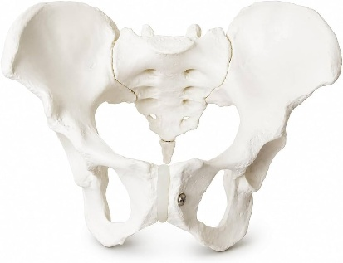
Despite these significant advances, pelvic girdle pain continues to represent a substantial clinical challenge, with many affected women experiencing delayed diagnosis, suboptimal treatment, and prolonged suffering that extends well beyond the expected recovery period. The delayed diagnosis that many women experience is particularly concerning, as early identification and intervention have been shown to be associated with better outcomes. Several factors contribute to delayed diagnosis, including the historical tendency to attribute all lumbopelvic pain during pregnancy to normal pregnancy discomfort, the lack of awareness among some healthcare providers regarding the specific signs and symptoms of pelvic girdle pain, and the overlap between pelvic girdle pain and other musculoskeletal conditions that can make differential diagnosis challenging. The consequences of delayed diagnosis include prolonged suffering, the development of chronic pain syndromes, progressive functional decline, and increased psychological distress. ^{[5]}

The condition affects women of all ages but is particularly prevalent during pregnancy and the postpartum period, when hormonal and mechanical changes place exceptional demands on the pelvic girdle's stabilizing structures. During pregnancy, the combined effects of relaxin and other hormones on connective tissue laxity, the increasing mechanical load imposed by the growing uterus, and the postural adaptations required to accommodate the changing center of gravity all contribute to creating a physiological environment in which the pelvic girdle is particularly vulnerable to dysfunction. ^{[6]}

The impact of pelvic girdle pain extends far beyond the individual affected woman, influencing family dynamics, occupational productivity, healthcare resource utilization, and broader societal costs. Women with pelvic girdle pain may require assistance from family members with basic daily tasks, may need to take extended periods of sick leave from work, and may require ongoing healthcare services including physiotherapy, pain management, and psychological support. The cumulative economic burden of pelvic girdle pain is substantial, encompassing both the direct costs of healthcare provision and the indirect costs associated with lost productivity, reduced work capacity, and the need for social support services. ^{[7]}
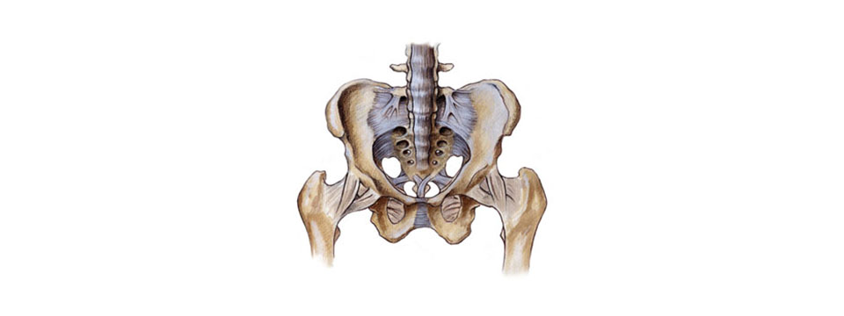
Hippocrates described pelvic pain in pregnant women, noting the relationship between the physiological changes of pregnancy and the development of musculoskeletal symptoms in the pelvic region. Throughout the centuries, various theories have been proposed to explain the mechanisms underlying pelvic pain during pregnancy, ranging from humoral imbalances in ancient medicine to specific hormonal and biomechanical mechanisms in contemporary medical science. However, it is only in recent decades that systematic research has been conducted to understand the underlying mechanisms, develop validated diagnostic criteria, and evaluate the effectiveness of specific therapeutic interventions. ^{[8]}

This growing body of research has transformed the way pelvic girdle pain is conceptualized, diagnosed, and managed, moving from a narrow focus on structural pathology to a more comprehensive biopsychosocial understanding that incorporates biomechanical, neuromuscular, hormonal, psychological, and social dimensions. The biopsychosocial model, which recognizes that pain and disability arise from the complex interaction of biological, psychological, and social factors, has become the dominant paradigm in contemporary musculoskeletal rehabilitation, and its application to pelvic girdle pain has led to significant advances in treatment approaches, including the development of graded activity-based physiotherapy programs that address multiple dimensions of the condition simultaneously. ^{[9]}

The significance of pelvic girdle pain as a clinical and public health issue is underscored by its high prevalence, substantial functional impact, and the considerable healthcare resources devoted to its management. For individual women, the condition can transform what should be a joyful and fulfilling period of pregnancy and early motherhood into an experience dominated by pain, limitation, frustration, and isolation. The inability to perform basic daily activities, participate fully in family life, fulfill occupational responsibilities, and engage in social and recreational activities can have profound effects on mental health, self-esteem, maternal-infant bonding, and overall well-being. ^{[10]}

The management of pelvic girdle pain has evolved significantly over the past several decades. Traditional approaches focused primarily on rest, supportive devices such as pelvic belts and corsets, symptomatic pain relief through pharmacological interventions, and avoidance of activities that provoked symptoms. These passive and rest-based approaches were based on the assumption that the pelvic joints were inherently unstable, and that protection and rest were necessary to allow healing. However, this approach has been largely discredited by contemporary research, which has demonstrated that prolonged rest leads to muscle atrophy, connective tissue weakening, cardiovascular deconditioning, and psychological dependence on passive interventions, all of which can contribute to the perpetuation of pain and disability. ^{[11]}
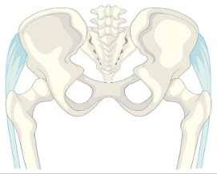
Contemporary management of pelvic girdle pain emphasizes active rehabilitation, progressive loading, comprehensive patient education, and the restoration of functional capacity as primary goals. This paradigm shift has been driven by a growing evidence base demonstrating that active interventions, particularly those incorporating graded activity principles, produce superior functional outcomes compared to passive or rest-based approaches. The graded activity approach, which originated in the behavioral management of chronic pain and has been adapted for musculoskeletal rehabilitation, provides a structured framework for progressively increasing physical activity and functional engagement while addressing the psychological barriers to recovery, including fear of movement, catastrophizing, and low self-efficacy. ^{[12]}

The development and evaluation of graded activity-based physiotherapy programs for women with pelvic girdle pain represents an important area of ongoing research in musculoskeletal physiotherapy. Multiple studies have examined the effectiveness of various exercise-based interventions for pelvic girdle pain, with generally positive results. However, relatively few studies have explicitly incorporated the full range of graded activity principles into their treatment protocols, and there remains a need for further research to optimize the design, implementation, and evaluation of graded activity programs for this population. ^{[13]}
Definition
The European Guidelines on Pelvic Girdle Pain, published in 2008, represent the most comprehensive and internationally recognized attempt to standardize the definition, diagnosis, and treatment of this condition. These guidelines, developed through a collaborative effort involving leading researchers and clinicians from multiple European countries, provide a consensus-based framework that has been widely adopted in clinical practice and research settings worldwide. According to these guidelines, pelvic girdle pain is defined as pain experienced between the posterior iliac crest and the gluteal fold, particularly in the vicinity of the sacroiliac joints. ^{[1]}

The European Guidelines further specify that the pain may or may not be accompanied by pain in the pubic symphysis, which is located anteriorly at the front of the pelvis. In some cases, the pain may radiate to the posterior thigh, extending as far as the knee but typically not below the knee, and it is this characteristic distribution that helps to distinguish pelvic girdle pain from other causes of low back and pelvic pain, including lumbar radiculopathy, which typically produces pain that radiates below the knee. The European Guidelines further specify that pelvic girdle pain is a specific classification of musculoskeletal pain that is distinct from pregnancy-related low back pain, which refers to pain experienced specifically in the lumbar region above the level of the posterior iliac crest. The differentiation of pelvic girdle pain is based on the location of pain, the pattern of symptom provocation during clinical testing, and the response to specific therapeutic interventions. ^{[2]}

Historically, pelvic girdle pain has been described using a variety of terms, reflecting the condition and the involvement of different anatomical structures. These terms include sacroiliac joint dysfunction, pelvic instability, symphysis pubis dysfunction, pelvic arthropathy, pregnancy-related pelvic pain, posterior pelvic pain, and combined pelvis syndrome, among others. Each of these terms reflects a particular emphasis or theoretical framework, but none captures the full complexity of the condition. The adoption of the standardized term "pelvic girdle pain" reflects a broader recognition that the condition involves multiple anatomical structures within the pelvic ring, including both sacroiliac joints and the pubic symphysis, as well as the associated ligamentous, muscular, and neural structures. This terminological standardization has facilitated improved communication among healthcare providers, more consistent diagnostic criteria across research studies, and the development of evidence-based treatment guidelines. ^{[4]}
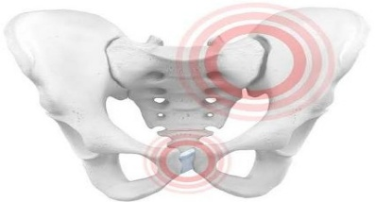
The definition of pelvic girdle pain also encompasses the temporal dimension of the condition. While most commonly associated with pregnancy and the postpartum period, the condition can occur in non-pregnant women following trauma such as motor vehicle accidents, falls, or sports injuries can develop insidiously without any identifiable precipitating event or can persist as a chronic condition following an episode of pregnancy-related pelvic girdle pain that failed to resolve adequately. The temporal variability of the condition underscores the importance of a comprehensive and flexible approach to both diagnosis and treatment, as the optimal management strategy may differ depending on the temporal pattern, precipitating factors, and duration of symptoms. ^{[5]}

The definition of pelvic girdle pain is further refined by the recognition of subgroups or classifications within the broader diagnostic category. Albert and colleagues developed a classification system that identifies four distinct presentations based on the number and location of symptomatic pelvic joints:
- pelvic girdle syndrome pain
- symphyseal pain
- one-sided sacroiliac syndrome
- double-sided sacroiliac syndrome
This classification system has prognostic value, as women with pelvic girdle syndrome tend to have the most severe symptoms, the longest duration of pain, and the poorest functional outcomes. ^{[6]}

Ligamentous Support and Force Closure
The stability of the pelvic girdle is maintained through two interrelated mechanisms: form closure and force closure. Form closure refers to the inherent passive stability provided by the precise anatomical fit between the sacrum and the iliac bones, while force closure refers to the dynamic stability provided by the coordinated activation of muscles, fascia, and ligaments that compress the sacroiliac joints during functional activities. ^{[20]}

Muscular Control and Neuromuscular Integration
The muscular system of the lumbopelvic region constitutes a complex network of local and global muscles that work in coordinated synergy to maintain pelvic girdle stability during static and dynamic activities. ^{[29]}

The pelvic floor muscles work in coordination with the diaphragm and abdominal wall muscles to regulate intra-abdominal pressure, creating a hydraulic mechanism that stabilizes the lumbopelvic region. ^{[33]}

Load Transfer During Functional Activities
The pelvic girdle serves as the primary structure for load transfer between the upper body and the lower extremities during all weight-bearing activities. During walking, the pelvis undergoes a complex pattern of movement that includes rotation, translation, and tilting in multiple planes. The sacroiliac joints undergo small degrees of nutation and counternutation during the gait cycle, providing shock absorption and load distribution. ^{[36]}

Biomechanical Changes During Pregnancy
During pregnancy, the biomechanics of the pelvic girdle undergo significant changes due to the combined effects of hormonal relaxation of connective tissue, altered postural alignment, and increased mechanical loading from the growing uterus. ^{[28]}

The increased mechanical load imposed by the growing uterus, combined with postural adaptations and hormonally induced ligamentous laxity, creates exceptional demands on the pelvic girdle's stabilizing mechanisms, potentially exceeding their adaptive capacity and resulting in pain and dysfunction. ^{[49]}

Epidemiology
The condition is significantly more common in women than in men, with the female-to-male ratio estimated at approximately 3:1 or higher for non-traumatic presentations. The gender difference reflects both anatomical and hormonal factors, as the female pelvis is structurally adapted for childbirth which affect the mechanical properties of the connective tissues supporting the pelvic joints. ^{[40]}

The age distribution of pelvic girdle pain follows a bimodal pattern, with the first and largest peak occurring during the reproductive years primarily associated with pregnancy and the postpartum period, and a second smaller peak occurring in later life associated with degenerative changes in the sacroiliac joints and the effects of hormonal changes associated with menopause. The first peak is directly related to the reproductive function of women, with the highest prevalence observed during the third trimester of pregnancy and the early postpartum period. The second peak is related to the cumulative effects of mechanical stress, age-related changes in connective tissue properties, and hormonal changes that affect ligamentous integrity. ^{[41]}

Prevalence in Women
During pregnancy, the reported prevalence of pelvic girdle pain ranges from 20% to 70%, depending on the diagnostic criteria employed and the timing of assessment. Studies that employ strict diagnostic criteria, including clinical examination with pain provocation tests, tend to report lower prevalence rates than studies based solely on self-reported symptoms. The variation in reported prevalence rates reflects differences in the definition and diagnostic criteria used, the timing of assessment during pregnancy, the method of data collection, and the population studied. This suggests that a substantial proportion of women who report pelvic pain during pregnancy may have conditions other than true pelvic girdle pain, including lumbar pain, hip pathology, or non-musculoskeletal sources of pelvic pain. ^{[38]}

Other studies have reported prevalence rates of 20% for significant pelvic girdle pain requiring treatment, while milder forms affecting daily activities have been reported in up to 50% of pregnancies. The variation in reported prevalence reflects not only differences in diagnostic criteria but also differences in the populations studied, the timing of assessment during pregnancy, and the cultural and genetic factors that may influence both the occurrence and the reporting of symptoms. ^{[37]}

The prevalence increases progressively from first trimester 7-10% through the second trimester 20-30%, to the third trimester 30-50%. This progressive increase reflects the cumulative effects of hormonal exposure and mechanical stress over the course of pregnancy, as well as the increasing weight and size of the uterus, which alters the center of gravity and increases the mechanical demands on the pelvic stabilizing structures. ^{[42]}

For most women, symptoms resolve spontaneously within the first three to six months following delivery. However, approximately 10% to 20% of women continue to experience significant pelvic girdle pain beyond this period, with some developing persistent chronic pain that extends for years following childbirth. Studies have reported that approximately 5-10% of women continue to experience significant symptoms at 12 months postpartum, with some studies reporting prevalence rates of approximately 30-40% at 3 months postpartum, 15-25% at 6 months postpartum, 5-10% at 12 months and 20% at 2 years. ^{[22]}

In addition to pregnancy-related pelvic girdle pain, the condition can also occur in non-pregnant women, typically as a result of trauma, repetitive mechanical stress, or inflammatory conditions affecting the sacroiliac joints with estimated prevalence rates of 15-25%. ^{[44]}

Several factors influence the reported prevalence rates across different studies and populations. These include the diagnostic criteria employed, the timing and method of assessment, cultural and genetic factors, occupational demands, and access to healthcare. The variation in reported prevalence underscores the need for standardized diagnostic criteria and assessment tools to facilitate meaningful comparisons across studies and populations. ^{[45]}

The natural history of pelvic girdle pain follows several possible trajectories. The most favorable outcome is spontaneous resolution following delivery, which occurs in the majority of cases 80-90%. A less favorable trajectory involves persistence of symptoms beyond the expected postpartum recovery period, leading to chronic pain and disability 10-20% of cases. An intermediate trajectory involves partial improvement with residual symptoms that fluctuate over time, exacerbated by specific activities or physical demands 20-30% of cases. ^{[46]}

Common Causes
From a biomechanical perspective, pelvic girdle pain is thought to arise from insufficient force closure, resulting in excessive or asymmetrical movement at the sacroiliac joints or pubic symphysis. This insufficiency may result from impaired activation of the deep stabilizing muscles, fatigue of the global supporting muscles, or laxity of the ligamentous structures following hormonal influence or mechanical stress. ^{[22]}

When the force closure mechanism is insufficient to maintain adequate joint compression during functional activities, excessive stress is placed on the capsular and ligamentous structures of the pelvic joints, resulting in pain and reflexive muscle inhibition, which further compromises stability and perpetuates the cycle of dysfunction. ^{[57]}

Natural History and Prognosis
For most women who develop the condition during pregnancy, symptoms resolve spontaneously within the first three to six months following delivery. ^{[22]}

However, approximately 10% to 20% of women continue to experience significant pelvic girdle pain beyond this period, with some developing persistent chronic pain that extends for years following childbirth. Gutke and colleagues investigated factors predicting persistent pregnancy-related pelvic girdle pain, finding that higher pain intensity during pregnancy, higher disability levels, and a greater number of positive pain provocation tests were associated with ongoing pain at six months postpartum. ^{[43]}

Björklund and Bergström examined whether pelvic pain in pregnancy predicts pain in future pregnancies, finding that a history of pelvic girdle pain in a previous pregnancy was a strong predictor of recurrence. ^{[54]}
AIM OF THE PROJECT

AIM OF THE PROJECT
The aim of the study is to assess the effectiveness of graded activity-based physiotherapy in women with pelvic girdle pain on improving functional capacity.

OBJECTIVES

OBJECTIVES

Primary Objective
To evaluate the effectiveness of graded activity-based physiotherapy in improving functional activity in women with pelvic girdle pain.

Secondary Objectives
- To assess the level of functional limitation in women with pelvic girdle pain before the intervention

- To evaluate changes in functional activity following graded activity-based physiotherapy

- To assess the effect of graded activity-based physiotherapy on pain intensity in women with pelvic girdle pain

- To evaluate improvements in the performance of daily activities, such as walking, standing, sitting, stair climbing, and transfers in women with pelvic girdle pain

- To compare pre-intervention and post-intervention functional activity scores in women with pelvic girdle pain

- To assess changes in activity tolerance and the ability to perform daily tasks following the intervention in women with pelvic girdle pain
REVIEW OF LITERATURE

REVIEW OF LITERATURE

- INNERVATION OF THE SACROILIAC JOINT OF THE HUMAN - Grob KR, Neuhuber WL, Kissling RO, Z Rheumatol; 117-22 - 1995

In this study the innervation of the human sacroiliac joint was investigated on adult cadaveric specimens devoted for routine dissection courses, and on fetuses obtained from therapeutic abor-tions. Gross anatomical and microscopic dissection, histology of dissected nerves, and histological and immunocytochemical approaches were used. Innervation of the iliosacral joint is provided by fine nerve branches derived exclusively from dorsal rami of spinal nerves S1-S4. No branches could be detected from the plexus sacralis and obturator nerve coursing over the ventral aspect of the joint. Nerves were distributed to superficial and deep dorsal sacroiliac ligaments, and to the sacrotuberous and sacrospinous ligaments. Dorsal spinal rami continued their course laterally, sandwiched between superficial and deep portions of sacroiliac ligaments, piercing the origin of the glutaeus maximus muscle. Histological examination of dissected nerves demonstrated numerous thick myelinated, besides thin myelinated and unmyelinated nerve fibers compatible with a broad repertoire of sensory receptors including encapsulated mechanoreceptors. Histological and immunocytochemical studies on fetal iliosacral joints showed neurofilament positive nerve fibers only in dorsal portions. This innervation pattern may provide explanations for various patterns of pseudoradicular and referred pain in affections of the sacroiliac joint.

- EUROPEAN GUIDELINES FOR THE DIAGNOSIS AND TREATMENT OF PELVIC GIRDLE PAIN - Vleeming, A., Albert, H.B., Östgaard, H.C. et al. European guidelines for the diagnosis and treatment of pelvic girdle pain. Eur Spine J 17, 794–819 - 2008

In this study a guideline on pelvic girdle pain (PGP) was developed by “Working Group 4” within the framework of the COST ACTION B13 “Low back pain: guidelines for its management”, issued by the European Commission, Research Directorate-General, Department of Policy, Coordination and Strategy. To ensure an evidence-based approach, three subgroups were formed to explore: (a) basic information, (b) diagnostics and epidemiology, and (c) therapeutical interventions. The progress of the subgroups was discussed at each meeting, and the final report is based on group consensus. A grading system was used to denote the strength of the evidence, based on the AHCPR Guidelines (1994) and levels of evidence recommended in the method guidelines of the Cochrane Back Review group. It is concluded that PGP is a specific form of low back pain (LBP) that can occur separately or in conjunction with LBP.
PGP generally arises in relation to pregnancy, trauma, arthritis and/or osteoarthritis. Uniform definitions are proposed for PGP as well as for joint stability. The point prevalence of pregnant women suffering from PGP is about 20%. Risk factors for developing PGP during pregnancy are most probably a history of previous LBP, and previous trauma to the pelvis. There is agreement that non risk factors are: contraceptive pills, time interval since last pregnancy, height, weight, smoking, and most probably age. PGP can be diagnosed by pain provocation tests (P4/thigh thrust, Patrick’s Faber, Gaenslen’s test, and modified Trendelenburg’s test) and pain palpation tests (long dorsal ligament test and palpation of the symphysis). As a functional test, the active straight leg raise (ASLR) test is recommended. Mobility (palpation) tests, X-rays, CT, scintigraphy, diagnostic injections and diagnostic external pelvic fixation are not recommended. MRI may be used to exclude ankylosing spondylitis and in the case of positive red flags. The recommended treatment includes adequate information and reassurance of the patient, individualized exercises for pregnant women and an individualized multifactorial treatment program for other patients.

- RELATION BETWEEN FORM AND FUNCTION IN THE SACROILIAC JOINT. PART I: CLINICAL ANATOMICAL ASPECTS - A Vleeming et al. Spine (Phila Pa 1976) - 1990

In this study observations on sectioned and opened preparations of human sacroiliac joints (SI joints) show the presence of cartilage-covered ridges and depressions, which are complementary on the auricular surfaces. These macroscopically visible features of the joints, which become visible relatively early in life, are more pronounced in men than in women. This type of roughening, as well as that by increased coarseness of the auricular surface, is viewed as a nonpathologic adaptation to the forces exerted at the SI joints, leading to increased stability. Differences between men and women may be attributed to childbearing and to a difference in the center of gravity. It is emphasized that intra-articular ridges and depressions can be misinterpreted roentgenologically as osteophytes.

- BIOMECHANICAL ANALYSIS OF REDUCING SACROILIAC JOINT SHEAR LOAD BY OPTIMIZATION OF PELVIC MUSCLE AND LIGAMENT FORCES - Pel, J.J.M., Spoor, C.W., Pool-Goudzwaard, A.L. et al, Ann Biomed Eng 36 - 2008

In this study effective stabilization of the sacroiliac joints (SIJ) is essential, since spinal loading is transferred via the SIJ to the coxal bones, and further to the legs. We performed a biomechanical analysis of SIJ stability in terms of reduced SIJ shear force in standing posture using a validated static 3-D simulation model. This model contained 100 muscle elements, 8 ligaments, and 8 joints in trunk, pelvis, and upper legs. Initially, the model was set up to minimize the maximum muscle stress. In this situation, the trunk load was mainly balanced between the coxal bones by vertical SIJ shear force. An imposed reduction of the vertical SIJ shear by 20% resulted in 70% increase of SIJ compression force due to activation of hip flexors and counteracting hip extensors. Another 20% reduction of the vertical SIJ shear force resulted in further increase of SIJ compression force by 400%, due to activation of the transversely oriented M. transversus abdominis and pelvic floor muscles. The M. transversus abdominis crosses the SIJ and clamps the sacrum between the coxal bones. Moreover, the pelvic floor muscles oppose lateral movement of the coxal bones, which stabilizes the position of the sacrum between the coxal bones (the pelvic arc). Our results suggest that training of the M. transversus abdominis and the pelvic floor muscles could help to relieve SI-joint related pelvic pain.

- THE ROLE OF THE HORMONE RELAXIN IN HUMAN REPRODUCTION AND PELVIC GIRDLE RELAXATION - MacLennan AH, Scand J Rheumatol Suppl; 88:7-15 - 1991

This study says relaxin is a polypeptide hormone produced in the human female by the corpus luteum of pregnancy and the decidua. In the male it is produced in the prostate and is present in human semen. It probably plays a paracrine role in the human and thus peripheral serum levels may not always reflect its activity. Although a large amount of pelvic relaxation is necessary in some species, such as rodents, for successful parturition, little increased joint mobility is necessary at human parturition. However, some women experience much greater degrees of pelvic girdle relaxation on average and this appears to be more common in the Scandinavian countries than the rest of the world. Studies are presented showing an association between high serum relaxin levels and symptom giving pelvic girdle relaxation during pregnancy. It is not yet possible to measure relaxin receptors in these women but high levels of relaxin or a susceptibility to relaxin may be contributing to this problem. Before considering manipulating relaxin levels or down grading relaxin receptors to try to improve the symptoms of pelvic girdle relaxation it is important to understand the many other roles of relaxin in the human. Evidence is presented that suggests that relaxin may have significant roles in sperm motility, fertilisation, implantation, uterine growth and accommodation, the control of myometrial activity to prevent preterm labour, cervical ripening and the facilitation of labour. The management of pelvic girdle relaxation is discussed.

- THE THORACOLUMBAR FASCIA: ANATOMY, FUNCTION AND CLINICAL CONSIDERATIONS - F. H. Willard, A. Vleeming, M. D. Schuenke, L. Danneels, R. Schleip - 2012

In this study, new and existent material on the organization and composition of the thoracolumbar fascia (TLF) will be evaluated in respect to its anatomy, innervation biomechanics and clinical relevance. The integration of the passive connective tissues of the TLF and active muscular structures surrounding this structure are discussed, and the relevance of their mutual interactions in relation to low back and pelvic pain reviewed. The TLF is a girdling structure consisting of several aponeurotic and fascial layers that separates the paraspinal muscles from the muscles of the posterior abdominal wall. The superficial lamina of the posterior layer of the TLF (PLF) is dominated by the aponeuroses of the latissimus dorsi and the serratus posterior inferior. The deeper lamina of the PLF forms an encapsulating retinacular sheath around the paraspinal muscles. The middle layer of the TLF (MLF) appears to derive from an intermuscular septum that developmentally separates the epaxial from the hypaxial musculature. This septum forms during the fifth and sixth weeks of gestation. The paraspinal retinacular sheath (PRS) is in a key position to act as a ‘hydraulic amplifier’, assisting the paraspinal muscles in supporting the lumbosacral spine. This sheath forms a lumbar interfascial triangle (LIFT) with the MLF and PLF. Along the lateral border of the PRS, a raphe forms where the sheath meets the aponeurosis of the transversus abdominis. This lateral raphe is a thickened complex of dense connective tissue marked by the presence of the LIFT and represents the junction of the hypaxial myofascial compartment (the abdominal muscles) with the paraspinal sheath of the epaxial muscles. The lateral raphe is in a position to distribute tension from the surrounding hypaxial and extremity muscles into the layers of the TLF. At the base of the lumbar spine all of the layers of the TLF fuse together into a thick composite that attaches firmly to the posterior superior iliac spine and the sacrotuberous ligament. This thoracolumbar composite (TLC) is in a position to assist in maintaining the integrity of the lower lumbar spine and the sacroiliac joint. The three-dimensional structure of the TLF and its caudally positioned composite will be analyzed in light of recent studies concerning the cellular organization of fascia, as well as its innervation. Finally, the concept of a TLC will be used to reassess biomechanical models of lumbopelvic stability, static posture and movement.

- THE RELATION BETWEEN THE TRANSVERSUS ABDOMINIS MUSCLES, SACROILIAC JOINT MECHANICS, AND LOW BACK PAIN - Carolyn A. Richardson, Chris J. Snijders, Julie A. Hides, Léonie Damen, Martijn S. Pas, Joop Storm - 2002

This study says contraction of the transversus abdominis significantly decreases the laxity of the sacroiliac joint. This decrease in laxity is larger than that caused by a bracing action using all the lateral abdominal muscles. These findings are in line with the authors’ biomechanical model predictions and support the use of independent transversus abdominis contractions for the treatment of low back pain.

- POSTURAL AND RESPIRATORY FUNCTIONS OF THE PELVIC FLOOR MUSCLES - P.W. Hodges X, R. Sapsford, L.H.M. Pengel - 2007

This study says EMG activity of the PFM was increased in advance of deltoid muscle activity as a component of the pre-programmed anticipatory postural activity. This activity was independent of the direction of arm movement. During repetitive movements, PFM EMG was tonic with phasic bursts at the frequency of arm movement. This activity was related to the peak acceleration of the arm, and therefore the amplitude of the reactive forces imposed on the spine. Respiratory activity was observed for the anal and vaginal EMG and was primarily expiratory. When subjects moved the arm repetitively while breathing, PFM EMG was primarily modulated in association with arm movement with little respiratory modulation

- CO-ACTIVATION OF THE ABDOMINAL AND PELVIC FLOOR MUSCLES DURING VOLUNTARY EXERCISES - R.R. Sapsford X, P.W. Hodges, C.A. Richardson, D.H. Cooper, S.J. Markwell, G.A. Jull - 2000

This study says the response of the abdominal muscles to voluntary contraction of the pelvic floor (PF) muscles was investigated in women with no history of symptoms of stress urinary incontinence to determine whether there is co-activation of the muscles surrounding the abdominal cavity during exercises for the PF muscles. Electromyographic (EMG) activity of each of the abdominal muscles was recorded with fine-wire electrodes in seven parous females. Subjects contracted the PF muscles maximally in three lumbar spine positions while lying supine. In all subjects, the EMG activity of the abdominal muscles was increased above the baseline level during contractions of the PF muscles in at least one of the spinal positions. The amplitude of the increase in EMG activity of obliquus externus abdominis was greatest when the spine was positioned in flexion and the increase in activity of transversus abdominis was greater than that of rectus abdominis and obliquus externus abdominis when the spine was positioned in extension. In an additional pilot experiment, EMG recordings were made from the pubococcygeus and the abdominal muscles with fine-wire electrodes in two subjects during the performance of three different sub-maximal isometric abdominal muscle maneuvers. Both subjects showed an increase in EMG activity of the pubococcygeus with each abdominal muscle contraction. The results of these experiments indicate that abdominal muscle activity is a normal response to PF exercise in subjects with no symptoms of PF muscle dysfunction and provide preliminary evidence that specific abdominal exercises activate the PF muscles.

- THE EFFECTS OF MANUAL PELVIC COMPRESSION ON TRUNK MOTOR CONTROL DURING AN ACTIVE STRAIGHT LEG RAISE IN CHRONIC PELVIC GIRDLE PAIN SUBJECTS - Darren John Beales et al. Man Ther - 2010

In this study a sub-group of pelvic girdle pain (PGP) patients with a positive active straight leg raise (ASLR) responds positively to the application of external pelvic compression during the test. This study investigated the effect of this phenomenon on electromyographic (EMG) activity of the trunk muscles and intra-abdominal and intra-thoracic pressures in subjects with a unilateral sacroiliac joint (SIJ) pain disorder (n=12). All subjects reported reduced difficulty ratings during an ASLR with pelvic compression (paired t-test: p<0.001), yet no statistically significant changes in the muscle activation or pressure variables were found. However, visual inspection of the data revealed two divergent motor control strategies with the addition of compression. Seven subjects displayed characteristics of a decreased EMG profile, while in the other five subjects the EMG profile appeared to increase.

As such this study provides preliminary evidence of two disparate patterns of motor control in response to the addition of pelvic compression to an ASLR. The findings may reflect different mechanisms, not only in the response to pelvic compression, but also of the underlying PGP disorder.

- PELVIC PAIN DURING PREGNANCY IS ASSOCIATED WITH ASYMMETRIC LAXITY OF THE SACROILIAC JOINTS - Léonie Damen X, H. Muzaffer Buyruk, Füsun Güler-Uysal, Frederik K. Lotgering, Chris J. Snijders, Hendrik J. Stam – 2008
This study says Sacroiliac joint (SIJ) pain is an underappreciated source of mechanical low back pain, affecting between 15 and 30% of individuals with chronic, nonradicular pain. Predisposing factors for SIJ pain include true and apparent leg length discrepancy, older age, inflammatory arthritis, previous spine surgery, pregnancy and trauma. Compared with facet-mediated and discogenic low back pain, individuals with SIJ pain are more likely to report a specific inciting event, and experience unilateral pain below L5. Owing in part to its size and heterogeneity, the pain referral patterns of the SIJ are extremely variable. Although no single physical examination or historical feature can reliably identify a painful SIJ, studies suggest that a battery of three or more provocation tests can predict response to diagnostic blocks. Evidence supports both intra- and extra-articular causes for SIJ pain, with clinical studies demonstrating intermediate-term benefit for both intra- and extra-articular steroid injections. In those who fail to experience sustained relief from SIJ injections, radiofrequency denervation may provide significant relief lasting up to 1 year. This review covers all aspects of SIJ pain, with the treatment section being primarily focused on procedural interventions.

ANATOMY AND BIOMECHANICS OF THE PELVIC GIRDLE

ANATOMY AND BIOMECHANICS OF THE PELVIC GIRDLE
The pelvic girdle is a complex anatomical structure that serves multiple critical functions within the human body. It provides structural support for the upper body, transmitting forces between the axial skeleton and the lower limbs during locomotion and weight-bearing activities. It provides attachment sites for numerous muscles of the trunk and lower limbs, enabling the generation of forces necessary for posture, movement, and stability. It encloses and protects the pelvic viscera, including the reproductive organs, urinary bladder, and rectum, providing a bony framework that shields these vital structures from external trauma. ^{[9]}
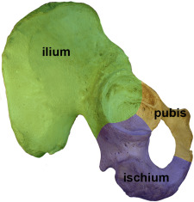
The pelvic girdle consists of two innominate bones, each formed by the fusion of three separate bones during development: the ilium, the ischium, and the pubis. These three bones fuse at the acetabulum, which is the cup-shaped socket that articulates with the head of the femur to form the hip joint. The two innominate bones articulate with each other anteriorly at the pubic symphysis and with the sacrum posteriorly at the sacroiliac joints, creating a complete bony ring that provides the structural foundation for the lower body. This ring-like configuration is essential for the load-bearing function of the pelvis, as the forces transmitted through the sacroiliac joints must be balanced by the integrity of the pubic symphysis anteriorly to maintain the structural stability of the ring. ^{[10]}
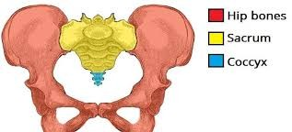
The sacrum, a triangular bone formed by the fusion of five sacral vertebrae, occupies a central position within the pelvic girdle and serves as the keystone of the pelvic ring. It is wedged shape, narrower superiorly and wider inferiorly, combined with the interlocking surfaces of the sacroiliac joints, creates a self-locking mechanism that provides inherent stability to the pelvic girdle during weight-bearing. This mechanism, known as self-bracing or form closure, provides passive stability without requiring muscular energy expenditure. ^{[11]}
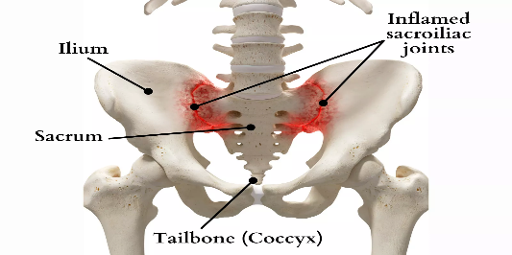
The coccyx, formed by the fusion of three to five rudimentary vertebrae, extends inferiorly from the sacrum and provides attachment for various ligaments and muscles of the pelvic floor, including the coccygeus muscle and portions of the levator ani. While the coccyx is a relatively small structure, it plays a role in weight-bearing during sitting and serves as an attachment point for structures that contribute to pelvic floor function. ^{[12]}
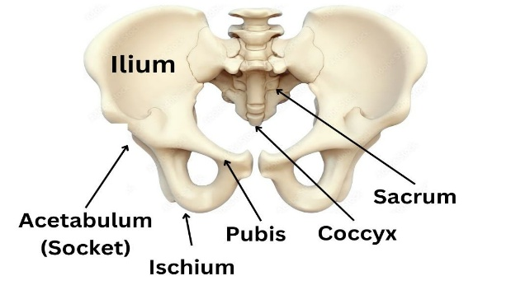⁼
The female pelvis is wider and shallower than the male pelvis, with a larger subpubic angle typically 80-90 degrees in females compared to 50-60 degrees in males, a more circular pelvic inlet, and a wider sciatic notch. These anatomical differences reflect the evolutionary adaptation for childbirth, as the female pelvis provides a larger birth canal to accommodate the passage of the fetal head during delivery. The wider female pelvis also results in altered force transmission patterns during gait and weight-bearing, potentially increasing the mechanical demands on the sacroiliac joints and pubic symphysis compared to the male pelvis. ^{[8]}
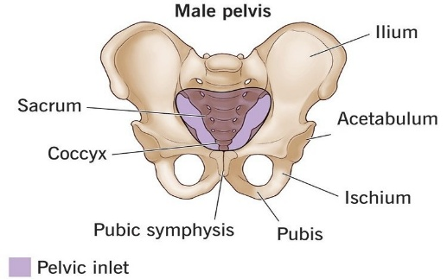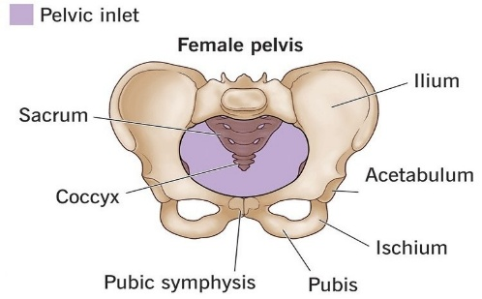
Structures Involved
Sacroiliac Joints
The sacroiliac joints represent the primary articulations within the posterior pelvic girdle, connecting the sacrum to the left and right iliac bones. The anterior portion of each sacroiliac joint is a true synovial joint, lined with hyaline cartilage on the sacral side and fibrocartilage on the iliac side, contained within a joint capsule and producing synovial fluid for lubrication. The posterior portion, which constitutes approximately two-thirds of the joint's surface area, is primarily a fibrous or syndesmotic articulation, with the two bones connected by dense interosseous ligaments rather than being separated by a joint cavity. The articular surfaces of the sacroiliac joints are irregular and interlocking, characterized by complementary ridges and depressions that fit together. The sacral surface is covered by relatively thick hyaline cartilage, approximately 3 millimeters in thickness, while the iliac surface is covered by thinner fibrocartilage, typically less than 1 millimeter in thickness. This approximately three-to-one ratio in cartilage thickness between the sacral and iliac surfaces is a distinctive feature of the sacroiliac joints and may contribute to the differential mechanical properties and nutritional status of the two joint surfaces. The asymmetry in cartilage thickness may also influence the pattern of force transmission through the joint and the distribution of mechanical stress within the joint structures. ^{[8]}
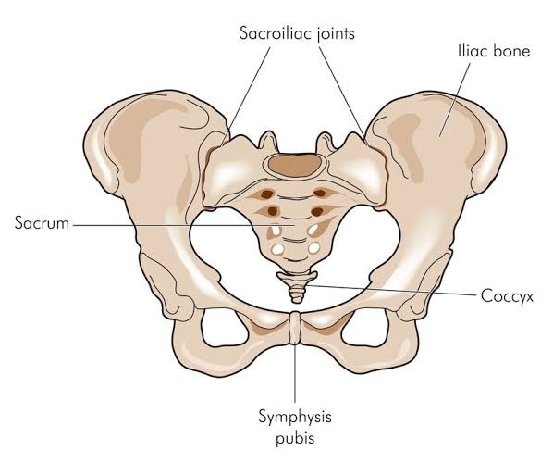
The wedged shape of the sacrum, combined with the irregular ridges and depressions on the joint surfaces, creates a self-locking mechanism that resists anterior-posterior shear forces during weight-bearing. This mechanism, known as form closure, provides passive stability to the joint without requiring muscular activation. The effectiveness of form closure depends on the congruence of the joint surfaces, the coefficient of friction between the articulating cartilage surface and the architecture of the sacrum within the pelvic ring. ^{[14]}
The sacroiliac joints permit very small ranges of motion, typically less than two to three millimeters of translation and two to three degrees of rotation. These movements, which include nutation and counternutation are essential for shock absorption and efficient load transfer during walking and other weight-bearing activities. ^{[15]}

During nutation, the sacrum rotates anteriorly and inferiorly relative to the iliac bones, causing the sacral promontory to move forward and the coccyx to move backward. This movement is accompanied by a slight widening of the pelvic outlet and a corresponding narrowing of the pelvic inlet. Counternutation involves the opposite pattern of movement, with the sacrum rotating posteriorly and the sacral promontory moving backward. These small movements play a crucial role in the biomechanics of the pelvic girdle during functional activities, providing a shock-absorbing mechanism that protects the spine and lower limbs from the impact forces of heel strike during gait. The limited range of motion reflects the tight structural constraints of the joint and the powerful ligamentous support that limits excessive movement. ^{[16]}
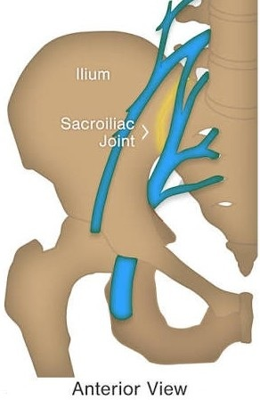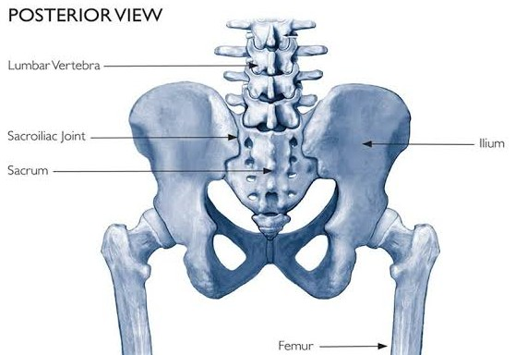
The blood supply to the sacroiliac joints is derived from branches of the internal iliac artery, specifically the iliolumbar artery, the lateral sacral arteries, and the superior and inferior gluteal arteries. The rich vascular supply to the joint region supports the metabolic needs of the various tissues and may contribute to the inflammatory responses that occur following injury or in inflammatory conditions. The venous drainage follows the arterial supply, with blood draining into the internal iliac veins. The innervation of the sacroiliac joints is complex and variable, involving contributions from the dorsal rami of the sacral nerves (L5-S3), the obturator nerve, and possibly the superior gluteal nerve. The posterior aspect of the joint is primarily innervated by the dorsal rami of S1-S3, while the anterior aspect receives innervation from the ventral rami and the obturator nerve. Pain from the sacroiliac joints may be felt locally in the region of the joint or may be referred to distant sites, including the buttock, posterior thigh, groin, and even the lower leg. ^{[17]}
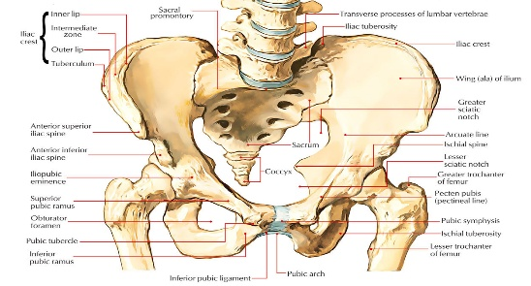
Pubic Symphysis
The pubic symphysis is a secondary cartilaginous joint located at the anterior aspect of the pelvic girdle. It connects the two pubic bones through a fibrocartilaginous disc that is reinforced by multiple ligaments. Under normal conditions, the pubic symphysis permits a small degree of movement, approximately one to two millimeters in total, which allows for slight accommodation of pelvic mechanics during locomotion, weight transfer, and changes in posture. ^{[18]}

The pubic symphysis is a complex joint that consists of the opposing surfaces of the two pubic bones, each covered by a thin layer of hyaline cartilage, separated by a fibrocartilaginous disc. The disc is thickest in the center and thinnest at the periphery, and it may contain a small central cavity that develops with age. The joint is stabilized by several ligaments, including the superior pubic ligament, the inferior pubic ligament also known as the arcuate ligament, which forms a strong arch beneath the joint), and the anterior and posterior pubic ligaments. ^{[19]}
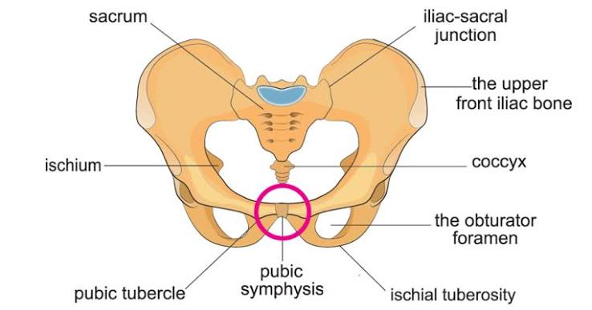
During pregnancy, the pubic symphysis undergoes significant changes under the influence of the hormone relaxin and other pregnancy hormones. The fibrocartilaginous disc becomes softer and more compliant, and the ligamentous support becomes more lax, resulting in increased joint mobility of up to four to five millimeters or more. The increased width of the pubic symphysis during pregnancy is a normal finding, with widths of up to 4-5 millimeters being considered within normal limits during pregnancy, compared to the non-pregnant average of 2-3 millimeters. While this increased mobility is a normal physiological adaptation that facilitates childbirth by allowing the pelvic outlet to expand during delivery, excessive mobility or separation can result in significant pain and functional impairment. ^{[20]}
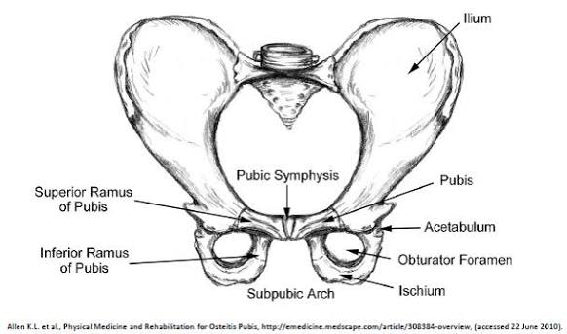
The phenomenon of symphyseal separation, in which the pubic symphysis widens significantly represents the extreme end of the spectrum of pubic symphysis dysfunction. This condition occurs in approximately 1 in 30,000 to 1 in 80,000 deliveries can produce severe pain, difficulty with weight-bearing, significant functional impairment, and may require extended recovery periods or in extreme cases surgical fixation. The diagnosis is confirmed by radiographic measurement of the symphyseal width or by clinical findings including a palpable gap at the symphysis. ^{[21]}

Ligaments
The ligamentous system of the pelvic girdle provides the primary passive stabilizing mechanism for the pelvic joints. The ligaments are composed of dense regular connective tissue, consisting primarily of collagen fibers arranged in parallel bundles, which provides them with high tensile strength and limited elasticity. The collagen fibers are primarily Type I collagen, which provides mechanical strength, with smaller amounts of Type III collagen and elastin fibers that provide some degree of compliance and recoil capability. ^{[22]}
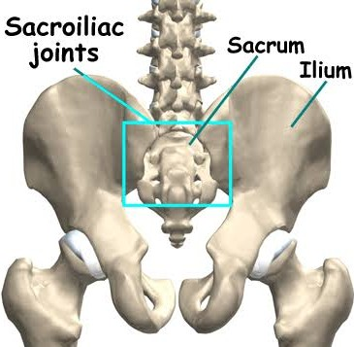
The sacroiliac joints are supported by several strong ligamentous structures that provide resistance to movement in specific directions. The anterior sacroiliac ligament, a broad flat structure that covers the anterior aspect of the joint capsule, provides resistance to anterior shear forces and excessive nutation. It is a relatively thin structure compared to the posterior ligaments and is considered the weakest of the sacroiliac ligaments. The posterior sacroiliac ligament complex, which is the strongest and most important of the sacroiliac ligaments, is composed of both superficial and deep layers. The superficial layer, also known as the long posterior sacroiliac ligament, extends from the posterior superior iliac spine to the lateral crest of the third and fourth sacral segments. This ligament provides resistance to posterior shear and counternutation forces. The deep layer, also known as the short posterior sacroiliac ligament or the interosseous sacroiliac ligament, fills the space between the sacrum and the iliac bone posterior to the joint, occupying the region known as the interosseous sulcus. ^{[23]}

Two additional ligaments, the sacrotuberous and sacrospinous ligaments, extend from the sacrum and coccyx to the ischial tuberosity and ischial spine, respectively. These ligaments convert the greater and lesser sciatic notches into the greater and lesser sciatic foramina. Through these foramina pass important neurovascular structures, including the sciatic nerve, the pudendal nerve, and the superior and inferior gluteal vessels. The sacrospinous ligament extends from the lateral border of the sacrum and coccyx to the ischial spine. It is a smaller, triangular ligament that lies anterior to the sacrotuberous ligament and provides resistance to excessive nutation of the sacrum. Together with the sacrotuberous ligament, it helps to maintain the position of the sacrum within the pelvic ring and provides attachment for muscles of the pelvic floor. ^{[24]}
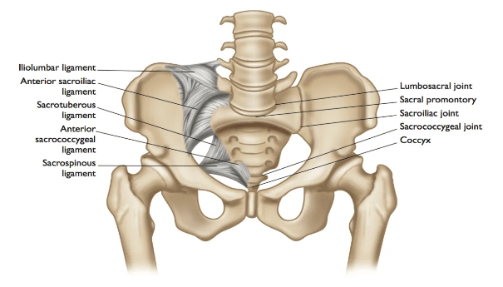
The sacrotuberous ligament is a large, strong ligament that extends from the posterior superior iliac spine, the posterior sacrum, and the coccyx to the ischial tuberosity. It has direct anatomical connections to the hamstring muscles through the biceps femoris tendon which attaches to the ischial tuberosity in close proximity to the ligament and to the posterior layer of the thoracolumbar fascia through which forces from the latissimus dorsi and gluteus maximus can be transmitted. These connections create a mechanical pathway through which muscular forces can influence sacroiliac joint mechanics, contributing to the integrated function of the pelvic girdle during whole-body movement and providing a mechanism for dynamic stabilization of the sacroiliac joint through muscular contraction. ^{[25]}
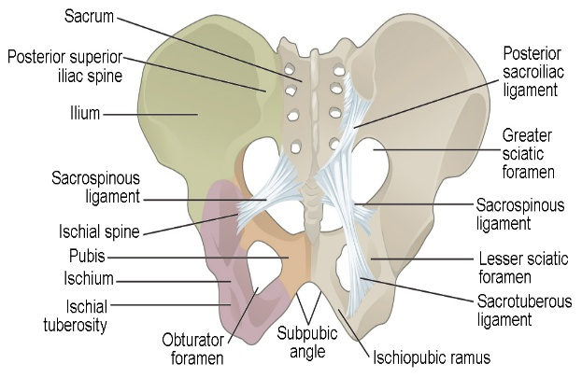
The thoracolumbar fascia consists of three layers: posterior, middle, and anterior, which collectively envelope the deep back muscles and create compartments that transmit forces between the upper body, the trunk, and the pelvis. The layer is composed of dense connective tissue that is continuous with the aponeurosis of the latissimus dorsi superiorly and with the fascia of the gluteus maximus inferiorly. The fascia attaches to the lumbar spinous processes, the sacral crest, the iliac crest, and the posterior superior iliac spine. The posterior layer is a continuation of the deep fascia of the back, extends from the lumbar spine to the sacrum and provides attachment for several key muscles, including the latissimus dorsi, gluteus maximus, and erector spinae. Tension within the thoracolumbar fascia, generated through contraction of the muscles attached to it, contributes to the compression of the sacroiliac joints, thereby enhancing their stability during functional activities. This mechanism, described as the myofascial force closure system, represents an important pathway through which muscular forces contribute to pelvic girdle stability. ^{[26]}
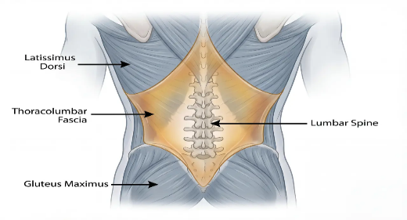
The inguinal ligament, which extends from the anterior superior iliac spine to the pubic tubercle, forms the floor of the inguinal canal and provides support for the anterior abdominal wall. While not directly involved in pelvic joint stability, the inguinal ligament plays a role in force transmission between the lower limb and the trunk and may be affected by postural changes associated with pelvic girdle dysfunction. The ligament also serves as a landmark for clinical examination and procedures in the inguinal region. ^{[27]}
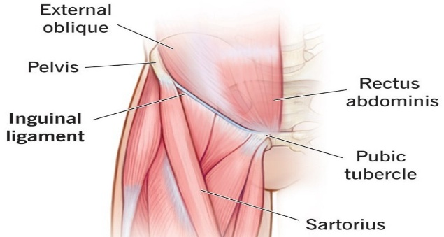
Muscles
The muscular system of the lumbopelvic region constitutes a complex network of local and global muscles that work in coordinated synergy to maintain pelvic girdle stability during static and dynamic activities. The classification of these muscles into local and global systems, originally proposed by Bergmark based on mechanical engineering principles, provides a useful framework for understanding their differential contributions to spinal and pelvic stability. The local muscles are deep, intrinsic muscles that attach directly to individual vertebrae or segments of the pelvis, controlling inter-segmental motion and providing fine adjustments to joint position. The global muscles are larger, more superficial muscles that span multiple segments, generating gross movements of the trunk and limbs and controlling overall posture and orientation. ^{[28]}
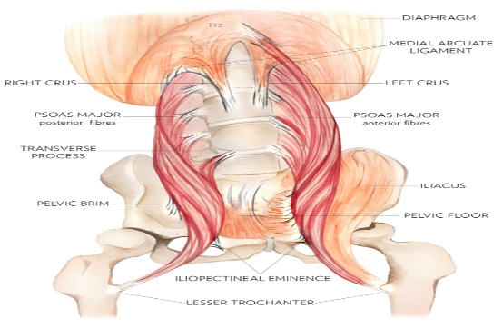
The local muscle system, rich in slow-twitch (Type I) muscle fibers are adapted for endurance, postural control and segmental stability, includes the transversus abdominis, the multifidus, the diaphragm, and the pelvic floor muscles. These muscles are characterized by their direct anatomical attachments to the lumbar vertebrae, sacrum, and pelvis, as well as their capacity for sustained, low-intensity contractions that maintain joint stiffness and stability. ^{[29]}
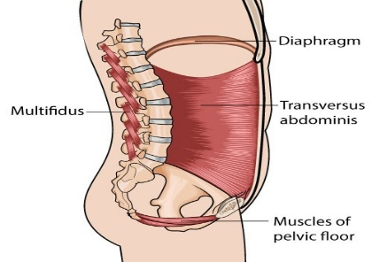
The transversus abdominis, the deepest of the abdominal muscles, plays a particularly important role in pelvic girdle stability. It arises from the inner surfaces of the seventh to twelfth costal cartilages, the lumbar fascia, the iliac crest, and the lateral third of the inguinal ligament, and inserts into the conjoint tendon and the linea alba. Its fibers run horizontally around the abdomen, creating a corset-like effect when contracted. Through its attachment to the thoracolumbar fascia and its horizontal fiber orientation, contraction of the transversus abdominis increases tension in the posterior fascial layer, which in turn generates compressive forces across the sacroiliac joints. This mechanism provides a direct link between abdominal muscle activation and pelvic girdle stability. The multifidus, a deep back muscle that consists of multiple fascicles that attach between adjacent vertebrae and from the sacrum to the lumbar vertebrae, contributes to the compressive stabilization of the sacroiliac joints through its segmental attachments and its rich concentration of muscle spindles, which provide proprioceptive feedback regarding joint position and movement. The multifidus is the largest and most medial of the lumbar intrinsic muscles, occupying the groove between the spinous and transverse processes. Fibers arise from the sacrum, the posterior superior iliac spine, and the mammillary processes of the lumbar vertebrae, and insert into the spinous processes of the vertebrae above. The multifidus is activated in anticipation of limb movement and demonstrates tonic activity during upright postures, suggesting a primary stabilizing role. ^{[31]}

The diaphragm, the primary muscle of respiration, forms the superior boundary of the abdomino-pelvic cavity and contributes to lumbopelvic stability through its role in generating intra-abdominal pressure. During inspiration, contraction of the diaphragm descends the dome of the diaphragm, compressing the abdominal contents and increasing intra-abdominal pressure. This increased pressure creates a pressurized cylinder within the abdominal cavity, where the diaphragm forms the roof, the abdominal wall muscles form the walls, and the pelvic floor muscles form the floor. This pressurized cylinder provides support for the lumbar spine and pelvic girdle during loading activities, effectively reducing the compressive load that must be borne by the passive structures of the spine and pelvis. ^{[32]}
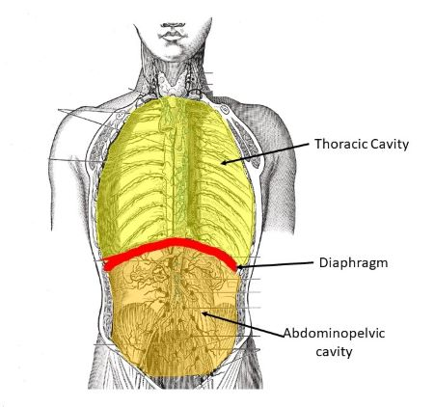
The pelvic floor muscles, including the levator ani which comprises the pubococcygeus, puborectalis, and iliococcygeus and the coccygeus, form the inferior boundary of the abdomino-pelvic cavity. These muscles originate from the pubic bones anteriorly, the ischial spines laterally, and the coccyx posteriorly, forming a sling that supports the pelvic viscera and contributes to the continence mechanism. The pelvic floor muscles work in coordination with the diaphragm and the abdominal wall muscles to regulate intra-abdominal pressure, creating a hydraulic mechanism that contributes to lumbopelvic stability during activities that increase intra-abdominal pressure, such as lifting, coughing, sneezing, and strenuous exercise. ^{[33]}
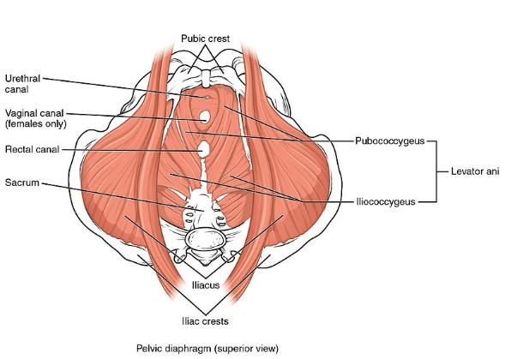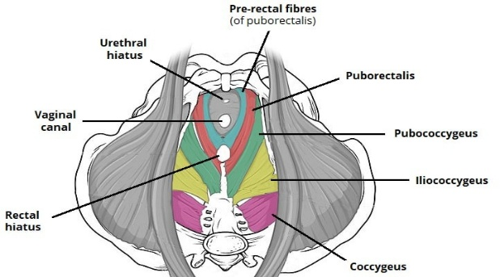
The global muscle system, which includes the rectus abdominis, external and internal obliques, erector spinae, latissimus dorsi, quadratus lumborum, gluteal muscles maximus, medius, and minimus, hip flexors iliopsoas and rectus femoris, hip extensors hamstrings, hip abductors gluteus medius, gluteus minimus, and tensor fasciae latae and hip adductors, produces movement and controls the overall orientation of the trunk and pelvis. These muscles are characterized by their larger size, greater force-generating capacity, multi-segmental attachments, and their role in dynamic activities requiring substantial force production. The global muscles are rich in fast-twitch (Type II) muscle fibers, which are adapted for rapid, forceful contractions, and they are activated in a direction-specific manner, producing movements that are appropriate to the task being performed. ^{[34]}
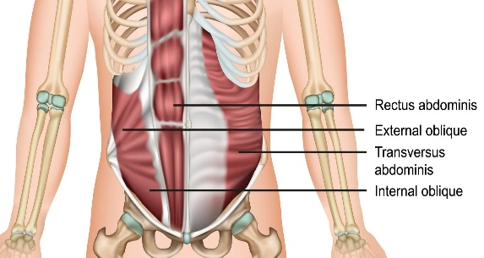
The gluteal muscles play a particularly important role in pelvic girdle stability during weight-bearing activities. The gluteus maximus, the largest and most superficial of the gluteal muscles, is a powerful hip extensor that also contributes to sacroiliac joint stability through its extensive attachment to the posterior layer of the thoracolumbar fascia and the sacrotuberous ligament. During activities such as walking, climbing stairs, and rising from sitting, contraction of the gluteus maximus extends the hip and simultaneously tensions the thoracolumbar fascia and the sacrotuberous ligament, contributing to the compression and stabilization of the sacroiliac joint. The gluteus medius and minimus, located deep to the gluteus maximus, act as the primary hip abductors and control frontal plane pelvic stability during single-leg weight-bearing. During the stance phase of gait, when one leg bears the body's weight while the other swings forward, the hip abductors of the stance leg contract to prevent the pelvis from dropping on the unsupported side knowns as Trendelenburg phenomenon. Weakness or inhibition of the hip abductors results in a characteristic compensatory pattern in which the trunk leans laterally toward the affected side during stance phase, increasing the mechanical demands on the lumbar spine and pelvis. ^{[35]}
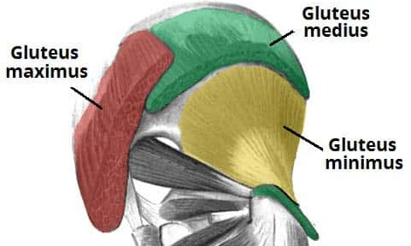
The hamstring muscles, particularly the biceps femoris, have a direct anatomical connection to the sacrotuberous ligament through their attachment at the ischial tuberosity. This connection creates a mechanical pathway through which hamstring contraction can influence sacroiliac joint mechanics, contributing to the integrated function of the pelvic girdle during whole-body movement. ^{[36]}
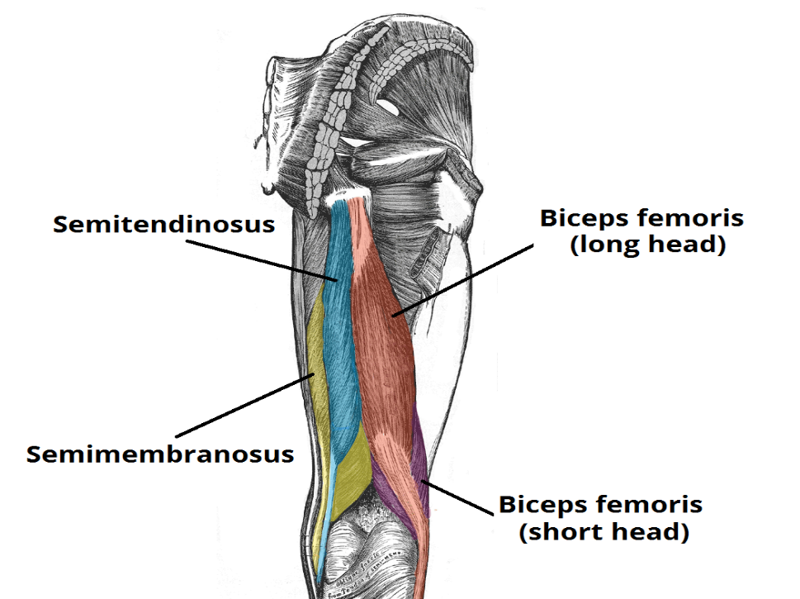

PELVIC GIRDLE PAIN: OVERVIEW

PELVIC GIRDLE PAIN: OVERVIEW
Definition
As defined by the European Guidelines, pelvic girdle pain refers to pain experienced between the posterior iliac crest and the gluteal fold, particularly in the vicinity of the sacroiliac joints.^{[1]}

The European Guidelines emphasize that pelvic girdle pain is distinct from pregnancy-related low back pain, which refers to pain experienced specifically in the lumbar region above the level of the posterior iliac crest. ^{[2]}

Albert and colleagues developed a widely used classification system for pregnancy-related pelvic pain based on the anatomical location of pain and clinical test results.
This system identifies four distinct presentations: pelvic girdle, symphyseal pain, one-sided sacroiliac syndrome, and double-sided sacroiliac syndrome. ^{[6]}

Etiology
The etiology of pelvic girdle pain is multifactorial, involving a complex interaction between hormonal, biomechanical, genetic, and psychosocial factors. The multifactorial nature of the condition explains the variability in presentation, severity, and response to treatment that is observed in clinical practice and highlights the importance of a comprehensive approach to assessment and management. ^{[25]}

Hormonal Causes
Relaxin, produced by the corpus luteum during pregnancy is a member of the insulin-like growth factor family of peptide hormones, and it exerts its effects through specific receptors on target cells. During pregnancy, relaxin levels increase reaching peak concentrations during the first trimester and maintaining elevated levels throughout pregnancy. The primary physiological role of relaxin during pregnancy is to promote the remodeling of connective tissue, particularly in the reproductive tract and the ligaments supporting the pelvic joints, to prepare the maternal body for delivery. The increase in ligamentous laxity that results from relaxin exposure is a normal and necessary physiological adaptation for pregnancy, as it allows the pelvic outlet to expand during delivery, facilitating the passage of the fetus through the birth canal. However, in some women, the laxity exceeds the capacity of the muscular stabilizing system, resulting in excessive joint mobility, mechanical stress on joint structures, and pain. ^{[26]}
Relaxin effects the connective tissue through specific receptors on target cells, where it activates intracellular signaling pathways that lead to the degradation of collagen and other extracellular matrix components. This process involves the upregulation of matrix metalloproteinases (MMPs), enzymes that break down the structural proteins of connective tissue, and the downregulation of tissue inhibitors of metalloproteinases (TIMPs), which prevent excessive tissue breakdown. This increase in tissue compliance and ligamentous laxity affects the sacroiliac ligaments, the sacrotuberous and sacrospinous ligaments, and the pubic symphyseal ligaments. ^{[47]}

In addition to relaxin, estrogen influences collagen synthesis and degradation, potentially affecting the mechanical properties of ligamentous structures throughout the body. Progesterone may also affect connective tissue metabolism, although its specific role in pelvic girdle laxity is less. The synergistic effects of these hormones, combined with relaxin, create a hormonal environment during pregnancy that promotes substantial remodeling and loosening of the connective tissues supporting the pelvic joints. ^{[48]}

Biomechanical Causes
The growing uterus during pregnancy shifts the body's center of gravity anteriorly and superiorly, necessitating compensatory postural adjustments, increased lumbar lordosis and anterior pelvic tilt. These postural changes alter the alignment and loading patterns of the sacroiliac joints, potentially contributing to joint dysfunction and pain. The increase in lumbar lordosis increases the compressive load on the facet joints and may alter the orientation of the sacrum within the pelvic ring changing the direction of forces transmitted through the sacroiliac joints. The postural changes also include compensatory adjustments in the thoracic spine, the cervical spine, and the lower limbs. These widespread postural changes affect the alignment and loading of the entire pelvic girdle. ^{[28]}

The increase in body weight during pregnancy, typically 10-15 kilograms represents a substantial increase in the mechanical load transmitted through the pelvic girdle during weight-bearing activities. The increased weight along with the hormonally induced ligamentous laxity increases the forces acting on the sacroiliac joints during single-leg weight-bearing activities, exceeding the capacity of the compromised stabilizing system. The distribution of the weight gain, which includes the growing fetus, the placenta, the amniotic fluid, increased blood volume, and maternal fat stores affect the center of gravity. ^{[49]}

Asymmetric laxity of the sacroiliac joints has also been identified as a contributing factor to pelvic girdle pain. This asymmetry may result from unequal hormonal effects on the two sides, pre-existing differences in joint anatomy or laxity, or asymmetric mechanical loading from occupational or postural factors. The asymmetric laxity creates a situation in which one sacroiliac joint is required to compensate for the excessive mobility of the other, potentially leading to overload, strain, and pain on the compensating side. ^{[29]}

Mechanical Stress and Trauma
Physical trauma such as falls, motor vehicle accidents, or childbirth itself, can produce direct injury to the sacroiliac joints, pubic symphysis, or associated ligamentous structures. The mechanism of injury typically involves sudden, high-magnitude forces that exceed the tensile strength of the ligamentous structures, resulting in partial or complete tears of ligament fibers, capsular damage, and in severe cases, fractures of the bony structures. ^{[30]}

Repetitive mechanical stress from occupational activities involving prolonged standing, heavy lifting, or asymmetric loading can contribute to the development of pelvic girdle pain over time. This type of cumulative mechanical stress is particularly relevant for women in physically demanding occupations, such as nursing, childcare, manual labor, and certain athletic activities. The repetitive loading can lead to progressive microtrauma to ligamentous and capsular structures, fatigue failure of the muscular stabilizing system, and ultimately the development of pain and functional impairment. ^{[50]}

Childbirth is considered a traumatic event for the pelvic girdle when labor is prolonged, instrumental delivery is required, or the infant is macrosomic. The mechanical forces exerted on the pelvic joints during delivery can produce microtrauma to the ligamentous and capsular structures, contribute to the exacerbation of hormonally induced laxity, and result in postpartum pelvic girdle pain. The position of delivery, the duration of the second stage of labor, and the use of epidural anesthesia can all influence the degree of mechanical stress placed on the pelvic girdle during childbirth. ^{[51]}
Inflammatory Causes
Inflammatory conditions affecting the sacroiliac joints, including sacroiliitis and various spondyloarthropathies such as ankylosing spondylitis, psoriatic arthritis, reactive arthritis, and enteropathic arthritis, can produce pelvic girdle pain. These conditions are characterized by inflammation of the joint surfaces and surrounding structures, resulting in pain, stiffness, and progressive functional limitation. Inflammatory pelvic girdle pain typically differs from mechanical pelvic girdle pain in its clinical presentation, being characterized by morning stiffness lasting more than 30 minutes, improvement with activity rather than rest, night pain that improves on getting up and moving around, and systemic features including fatigue, low-grade fever, and weight loss. ^{[52]}

Degenerative Causes
Osteoarthritis of the sacroiliac joints, while less common than osteoarthritis of the hip or knee, can produce chronic pelvic girdle pain, particularly in older individuals and in postmenopausal women. The degenerative process involves progressive loss of articular cartilage, osteophyte formation, subchondral bone sclerosis, and cyst formation, resulting in joint pain, stiffness, and progressive limitation of movement. The degenerative changes may be primary or secondary. The pain from sacroiliac osteoarthritis is typically chronic, deep, and aching, and may be exacerbated by prolonged standing, walking, and weight-bearing activities. ^{[53]}

Risk Factors
Several risk factors have been identified through epidemiological studies for the development and persistence of pelvic girdle pain. Risk factors can be categorized as non-modifiable such as age, genetics, and previous history and modifiable such as body weight, occupational demands, and physical activity levels. ^{[31]}

Previous History of Pelvic Girdle Pain
Recurrence rates of 85% or higher have been reported among women who experienced significant symptoms previously, suggesting that there is an underlying vulnerability that persists across pregnancies. This vulnerability may reflect constitutional factors persistent changes in joint mechanics following the initial episode, or incomplete recovery of the neuromuscular stabilizing system following previous episodes. ^{[54]}
History of Low Back Pain
A prior history of low back pain, either before or during a previous pregnancy, has been consistently identified as a significant risk factor for the development of pelvic girdle pain. A prior history of low back pain was the strongest predictor of developing pelvic girdle pain during pregnancy. The mechanism underlying this relationship may involve shared risk factors such as connective tissue laxity, impaired motor control, or deconditioning, the presence of subclinical dysfunction that becomes symptomatic during the additional stress of pregnancy, or the sensitization of the nervous system following previous episodes of pain, which lowers the pain threshold and increases susceptibility to new pain conditions. ^{[32]}

Multiparity
Increasing parity has been associated with a higher risk of pelvic girdle pain. Women who have had multiple pregnancies are more likely to experience the condition compared to primigravida women, with some studies reporting a dose-response relationship between the number of previous pregnancies and the risk of developing pelvic girdle pain. This increased risk may reflect cumulative mechanical stress on the pelvic girdle with successive pregnancies, the cumulative effects of repeated hormonal exposure on connective tissue properties, incomplete recovery of the muscular stabilizing system between pregnancies, or progressive laxity of the ligamentous structures with each successive episode of hormonally induced loosening. ^{[55]}

High Body Mass Index
The relationship between body mass index (BMI) and pelvic girdle pain appears to be dose-dependent, with higher BMI values associated with greater risk. The mechanism may involve increased compressive forces on the sacroiliac joints during weight-bearing, increased demand on the muscular stabilizing system, increased inflammatory mediators associated with adipose tissue, or mechanical difficulty in maintaining optimal posture and movement patterns in the presence of excess body weight. ^{[56]}

Occupational Factors
Physically demanding occupations involving prolonged standing, heavy lifting, or asymmetric loading, have been associated with an increased risk of pelvic girdle pain. The cumulative mechanical stress associated with such occupations can contribute to fatigue of the stabilizing muscles and progressive ligamentous strain, particularly in pregnant women whose connective tissues are already compromised by hormonal effects.
Specific occupational factors that have been identified as risk factors include:
- prolonged standing: more than 4 hours per day
- heavy lifting: more than 10 kilograms frequently shift work which may affect circadian rhythms and recovery capacity
- job dissatisfaction which may be a marker for psychosocial stress
The identification of occupational risk factors provides opportunities for workplace modifications and early interventions to reduce the risk of developing pelvic girdle pain. ^{[57]}

Emotional Distress and Psychological Factors
Psychological factors, including stress, anxiety, depression, and low job satisfaction, have been identified as contributing factors in the development and persistence of pelvic girdle pain. These factors may influence the experience of pain through their effects on pain modulation, muscle tension and coping behaviors. The relationship between psychological factors and pelvic girdle pain is likely bidirectional, with pain contributing to psychological distress and psychological distress exacerbating the pain experience. The recognition of these psychological factors has important implications for treatment, suggesting that comprehensive management should include psychological assessment and intervention alongside physical approaches. ^{[34]}

Genetic Factors
Variations in genes encoding for proteins involved in connective tissue metabolism, including collagen genes particularly COL1A1, COL1A2, and COL5A1 may influence ligamentous laxity and thereby affect an individual's risk of developing pelvic girdle pain during pregnancy. Genetic polymorphisms affecting collagen structure and metabolism may result in connective tissues that are more susceptible to hormonally induced laxity or that have a lower threshold for mechanical failure under stress. ^{[33]}

Age
Advanced maternal age has been associated with an increased risk of pelvic girdle pain in some studies, although the evidence is inconsistent and the relationship is complex. The relationship may reflect cumulative mechanical stress on the pelvic girdle over time, age-related changes in connective tissue properties reduced capacity of the neuromuscular system to adapt to the demands of pregnancy, or other age-related factors that affect tissue healing and recovery. However, other studies have not found a significant relationship between maternal age and pelvic girdle pain, suggesting that the effect of age may be modest compared to other risk factors. ^{[58]}

Trauma History
A history of pelvic trauma, motor vehicle accidents involving pelvic impact, or previous difficult deliveries particularly those involving shoulder dystocia or instrumental delivery, has been identified as a risk factor for the development of pelvic girdle pain. Such trauma can produce lasting damage to the ligamentous structures supporting the pelvic joints, including partial tears of ligament fibers, capsular laxity, and altered joint mechanics. Women with a history of significant pelvic trauma should be identified as a potentially high-risk group and offered appropriate preventive advice and early intervention. ^{[59]}

Clinical Features
The clinical presentation of pelvic girdle pain is characterized by a constellation of symptoms and physical findings that reflect dysfunction of the pelvic girdle's stabilizing and load transfer mechanisms. The clinical features can be organized into several categories
- pain characteristics: location, quality, intensity, temporal pattern, and provoking/relieving factors
- functional symptoms: subjective reports of instability, giving way, and difficulty with specific activities
- physical examination findings: tenderness, pain provocation with specific tests, and alterations in movement patterns and muscle activation.
The recognition of these clinical features is essential for accurate diagnosis, appropriate classification, and effective treatment planning. ^{[35]}

Pain Characteristics
The pelvic girdle pain is seen between the posterior iliac crest and the gluteal fold, in the region of one or both sacroiliac joints. This location is the most characteristic and diagnostic feature distinguishing it from lumbar pain and hip pain. The pain may be unilateral, bilateral or may shift from side to side. It may be accompanied by anterior pain at the pubic symphysis, which is located at the front of the pelvis, approximately 2-3 centimeters above the genital area. The distribution of pain is a key diagnostic feature that helps to distinguish pelvic girdle pain from other causes of lumbopelvic pain. The pain may be described as sharp and stabbing during certain movements and as a deep, persistent ache during rest and sustained postures. ^{[1]}

The intensity of pain in pelvic girdle pain can range from mild discomfort that is only noticeable during specific activities such as prolonged standing or climbing stairs to severe, disabling pain that significantly limits the patient's ability to perform any weight-bearing activity. The intensity is typically quantified using a visual analog scale (VAS) or a numeric pain rating scale (NPRS), with scores ranging from 0 as no pain to 10 as worst imaginable pain. Women with pelvic girdle pain commonly report pain intensities of 5-8 on this scale, with some reporting scores of 9-10 during exacerbations or during specific provocative activities. The intensity of pain is an important predictor of functional limitation, response to treatment, and risk of chronicity. ^{[33]}

The pain associated with pelvic girdle pain is characteristically provoked by specific functional activities that involve asymmetric or unilateral loading of the pelvis. Common pain-provoking activities include: standing on one leg when dressing, climbing stairs, getting into a bath, walking particularly for extended distances or on uneven surfaces, turning in bed rolling from one side to the other, getting in and out of a car which requires asymmetric weight transfer and pelvic rotation, getting out of bed transitioning from lying to sitting to standing, standing up from a chair particularly from a low chair, and prolonged sitting or standing which places sustained load on the pelvic joints. ^{[37]}

Many women report that the pain worsens first thing in the morning, improving somewhat with movement and activity, or worsens with prolonged activity or towards the end of the day. The morning stiffness typically lasts less than 30 minutes, which helps to distinguish mechanical pelvic girdle pain from inflammatory conditions. The pattern of pain throughout the day may provide diagnostic information regarding the underlying mechanism, with mechanical pain typically being activity-related and inflammatory pain being more constant and worse after rest. ^{[60]}

Functional Symptoms
Difficulty with weight-bearing through one leg is a common functional symptom that reflects the impaired load transfer through the pelvic girdle when asymmetric forces are applied. Women may describe an inability to stand on one leg to dress or to climb stairs using a reciprocal pattern. This difficulty reflects the impaired load transfer through the pelvic girdle when asymmetric forces are applied and is closely related to the altered mechanics of the sacroiliac joints during single-leg weight-bearing. The active straight leg raise test, which requires the patient to lift one leg while supine, effectively tests this same load transfer mechanism and is frequently positive in women with pelvic girdle pain. ^{[62]}

Physical Examination Findings
Physical examination of women with pelvic girdle pain typically reveals tenderness over the sacroiliac joints and/or pubic symphysis, pain provocation with specific clinical tests, and alterations in muscle activation and movement patterns. The systematic examination follows a structured protocol that includes observation of posture and gait, palpation of specific anatomical landmarks, pain provocation testing of the pelvic joints, functional testing of load transfer capacity, and assessment of muscle strength, flexibility, and motor control. ^{[63]}

The posterior pelvic pain provocation test (P4 test) is one of the most widely used and validated clinical tests for pelvic girdle pain. In this test, the patient lies supine with the hip flexed to 90 degrees and the knee flexed to approximately 90 degrees. The examiner stands on the side to be tested and places one hand on the patient's contralateral iliac crest to stabilize the pelvis, while the other hand is placed just proximal to the patient's knee. The examiner then applies a posteriorly directed force through the femur along the line of the femoral shaft, which transmits a posteriorly directed shear force to the sacroiliac joint on the same side. A positive test is indicated by reproduction of the patient's familiar pain in the region of the sacroiliac joint. The P4 test has been shown to have high sensitivity for identifying pelvic girdle pain, particularly during pregnancy. ^{[63]}

The active straight leg raise (ASLR) test, described by Mens and colleagues, assesses the ability of the pelvic girdle to transfer loads between the trunk and the lower extremity. In this test, the patient lies supine with legs straight and hip neutral. The patient is asked to lift one leg approximately 20 centimeters off the treatment table, keeping the knee straight, hold it, and then lower it. The patient rates the difficulty of the task on an 11-point scale with 0 = not difficult at all and 10 = unable to perform for each leg. A total score of 3 or higher is considered indicative of impaired pelvic girdle load transfer. The test can be repeated with manual pelvic compression applied by placing hands on both iliac crests and applying a medial compression force and improvement in the ease of the task with external compression provides additional evidence that the patient's symptoms are related to insufficient force closure and can benefit from interventions that enhance pelvic stability. ^{[64]}

Observation of posture and movement patterns may reveal compensatory strategies, such as a wide-based gait, reduced stride length, altered trunk and pelvic alignment and protective movement patterns during transitional movements. The women with pelvic girdle pain show a waddling gait with increased lateral displacement of the pelvis and reduced speed of forward progression. Palpation may reveal tenderness over the affected joints, increased or decreased muscle tone in the surrounding muscles, and alterations in the position of bony landmarks. ^{[65]}

Impact of PGP on Functional Activities
Walking and Mobility
Walking is one of the most commonly affected activities in women with pelvic girdle pain. The biomechanical demands of walking, including the reciprocal pelvic rotation, weight transfer from one leg to the other, the single-limb support phase and the alternating loading and unloading of the pelvic joints throughout the gait cycle place significant stress on the pelvic girdle's stabilizing mechanisms. Women with pelvic girdle pain often report reduced walking speed, decreased stride length, and an inability to walk for extended periods without rest. ^{[40]}

The altered waddling gait pattern is characterized by increased pelvic width during double support, reduced hip abduction range, decreased vertical displacement of the center of mass, reduced gait speed, and increased lateral displacement of the trunk. This pattern minimizes the range of motion required at the sacroiliac joints during walking, thereby reducing the mechanical stress on these joints and the associated pain. ^{[41]}

Many women with pelvic girdle pain describe having to ascend and descend stairs using a step-to pattern rather than a reciprocal pattern, which substantially increases the time and energy required for this common daily activity. During stair ascent, the lead leg must lift the entire body weight while the pelvic girdle on that side must stabilize against the torque produced by gravity acting on the unsupported opposite leg. This requires substantial force closure of the sacroiliac joints on the weight-bearing side, which is impaired. ^{[42]}

Transitional Movements
Transitional movements, which involve changing position from one posture to another, are consistently reported as among the most painful and challenging activities for women with pelvic girdle pain. These include turning in bed, rolling from side to side, transitioning from lying to sitting, getting in and out of bed, rising from a chair, and entering or exiting a vehicle.
Each of these movements involves complex coordinated patterns of pelvic rotation, weight transfer, and sequential muscle activation, and each presents specific challenges to the compromised pelvic girdle stabilizing system. ^{[43]}

Many women develop elaborate compensatory strategies, such as keeping their legs together when turning in bed to minimize the range of pelvic rotation required, using their arms to push off from surfaces to reduce the load that must be supported by the pelvic girdle, sitting on the edge of the bed and swinging both legs together to the floor rather than getting up by leading with one leg, and performing movements more slowly and deliberately to reduce the velocity and force requirements. These compensatory strategies reflect the severity of the functional limitation and may become habitual, persisting even after symptoms improve. ^{[44]}

The act of turning in bed involves sequential rotation of the trunk and pelvis, with movement initiated at the shoulders and transmitted through the spine to the pelvis and legs. This requires coordinated movement of all segments of the spine and pelvis, with the sacroiliac joints undergoing small degrees of relative rotation between the sacrum and the iliac bones. Women with pelvic girdle pain may experience sharp, severe pain during this movement, particularly at the moment when the pelvis rotates relative to the trunk. ^{[45]}

Self-Care and Domestic Activities
Basic activities of daily living requiring single-leg weight bearing, forward bending, or squatting are frequently limited by pelvic girdle pain. Women may need to sit down to dress, or they may lean against a wall or furniture for support during single-leg activities. Bathing and showering, especially when stepping into or out of a bath can be extremely difficult and may require the installation of assistive equipment such as grab bars or shower chairs. ^{[46]}

Household tasks such as vacuuming, laundry, and cleaning require combinations of bending, lifting, pushing and rotational movements creating asymmetric loading of the pelvis. Women with pelvic girdle pain may need to divide loads into smaller portions, avoid certain tasks altogether, or rely on assistance from family members. ^{[47]}

In the postpartum period the physical demands of infant care are frequent lifting from crib to shoulder level requiring forward flexion, bilateral arm elevation, and significant trunk stability, carrying while standing or walking requiring sustained trunk and pelvic stability, and positioning for feeding requiring sustained postures are associated with pelvic girdle pain. ^{[48]}

Occupational Function
Women whose work involves prolonged standing, walking, lifting, or physical activity may find themselves unable to perform their occupational duties during pregnancy or the postpartum period, requiring extended periods of sick leave. Studies have documented that a significant proportion of women with pelvic girdle pain during pregnancy require sick leave, with reported rates ranging from 20% to 60% depending on the severity of symptoms and the physical demands of the occupation. ^{[49]}

Psychosocial Impact
Sleep disturbance is common among women with pelvic girdle pain, as difficulty finding comfortable sleeping positions and pain during nocturnal movements can significantly disrupt sleep quality. The supine position may be uncomfortable due to direct pressure on the sacroiliac joints, side-lying may provoke pain on the dependent side, and turning in is described as one of the most painful activities. Poor sleep exacerbates pain sensitivity through its effects on pain modulation pathways, reduce coping capacity, and contribute to depression and anxiety, creating a negative feedback loop that perpetuates the overall burden of the condition. ^{[52]}
FUNCTIONAL LIMITATIONS ASSOCIATED WITH PELVIC GIRDLE PAIN

FUNCTIONAL LIMITATIONS ASSOCIATED WITH PELVIC GIRDLE PAIN

The functional consequences of pelvic girdle pain extend far beyond the experience of localized pelvic pain, affecting virtually every domain of daily activity and significantly impacting quality of life for affected women. ^{[39]}

Mobility Limitations
Walking is among the most commonly affected activities in women with pelvic girdle pain, with reduced walking speed, decreased stride length, and an inability to walk for extended periods without rest. ^{[40]}

The gait pattern may be visibly altered, with a characteristic "waddling" pattern that reflects compensatory strategies to reduce stress on the symptomatic pelvic joints. ^{[41]}

Stair climbing is particularly problematic, as this activity requires repeated single-leg weight bearing and significant force generation through the pelvic girdle. ^{[42]}

Transitional Movement Limitations
Transitional movements, including turning in bed, rolling from side to side, transitioning from lying to sitting, getting in and out of bed, rising from a chair, and entering or exiting a vehicle, are consistently reported as among the most painful and challenging activities [43].

Many women develop elaborate compensatory strategies, such as keeping their legs together when turning in bed or using their arms to push off from surfaces, which reflect the severity of their functional limitations. ^{[44]}

Self-Care and Domestic Activity Limitations
Basic activities of daily living requiring single-leg weight bearing, forward bending, or squatting are frequently limited. Dressing activities, bathing, and household tasks challenge the pelvic girdle's functional capacity. ^{[45]}
In the postpartum period, the inability to comfortably lift, carry, and care for an infant represents one of the most distressing functional limitations. ^{[46]}

Occupational Limitations
The impact of pelvic girdle pain on occupational function is substantial, with studies documenting high rates of sick leave among women with pelvic girdle pain [49].
The economic implications include lost productivity, healthcare utilization, and potential need for career modification. ^{[50]}

Psychosocial and Quality of Life Impact
The psychosocial consequences of pelvic girdle pain are increasingly recognized as important aspects of the overall impact of the condition, including fear of movement, depression, anxiety, and sleep disturbance. ^{[51]}

The cumulative effect of these physical, functional, and psychological limitations results in a significant reduction in overall quality of life. ^{[53]}

ASSESSMENT AND OUTCOME MEASURES

ASSESSMENT AND OUTCOME MEASURES
The European Guidelines on Pelvic Girdle Pain provide a structured framework for the clinical assessment of women presenting with pelvic girdle pain, encompassing history taking, physical examination, and the administration of appropriate outcome measures. ^{[1]}

The history should include detailed information about the location, character, intensity, and temporal pattern of pain, as well as specific functional limitations and screening for red flags and yellow flags. ^{[72]}

Physical Examination and Pain Provocation Tests
Physical examination includes a series of validated clinical tests designed to reproduce the patient's symptoms and confirm the diagnosis. Laslett and colleagues evaluated the diagnostic accuracy of individual provocation tests and combinations of tests for identifying sacroiliac joint pain. Their findings demonstrated that while individual tests have moderate diagnostic accuracy, the use of clusters of three or more positive tests substantially improves both sensitivity and specificity. Commonly used pain provocation tests include the posterior pelvic pain provocation test (P4), the sacroiliac compression test, the sacral thrust test, the thigh thrust test, and Gaenslen's test.^{[63]}

Active Straight Leg Raise Test
The ASLR test is one of the most widely used functional tests for pelvic girdle pain, assessing the patient's ability to transfer loads between the trunk and the lower extremity. The test involves the patient lying supine and lifting one leg approximately 20 centimeters off the treatment table while keeping the knee straight, rating the difficulty on an 11-point scale.^{[64]}

Physical Performance Measures
Physical performance tests provide objective information about functional capacity, including the 6-minute walk test, timed up-and-go test, and single-leg standing balance tests. ^{[76]}

Pain Assessment Tools
The Pain Drawing, in which patients mark the location of their pain on a body diagram, is useful for identifying the distribution of symptoms. ^{[73]}
Pain Intensity ^{[60]}
Visual Analog Scale
Numeric Pain Rating Scale

Visual Analog Scale (VAS)

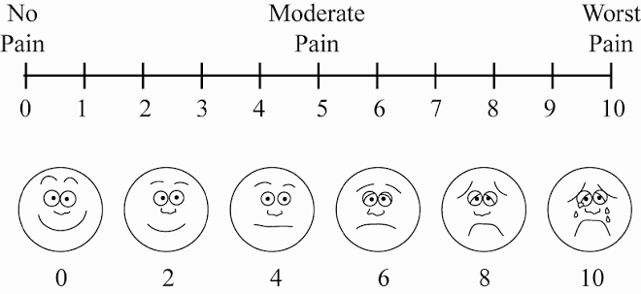

Numeric Pain Rating Scale (NPRS)
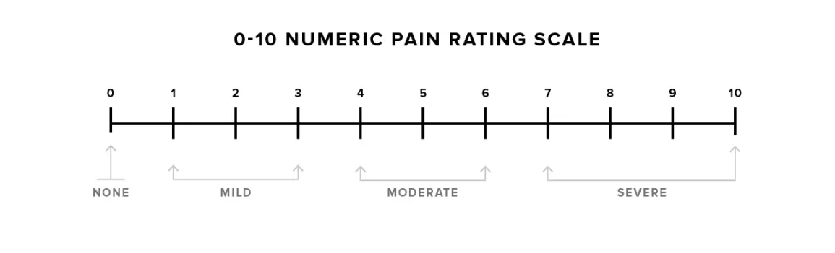

Functional Outcome Measures
Pelvic Girdle Questionnaire
The Pelvic Girdle Questionnaire (PGQ), developed by Kuijpers and colleagues, is a condition-specific instrument designed to assess symptoms and functional limitations in women with pregnancy-related pelvic girdle pain. ^{[61]}

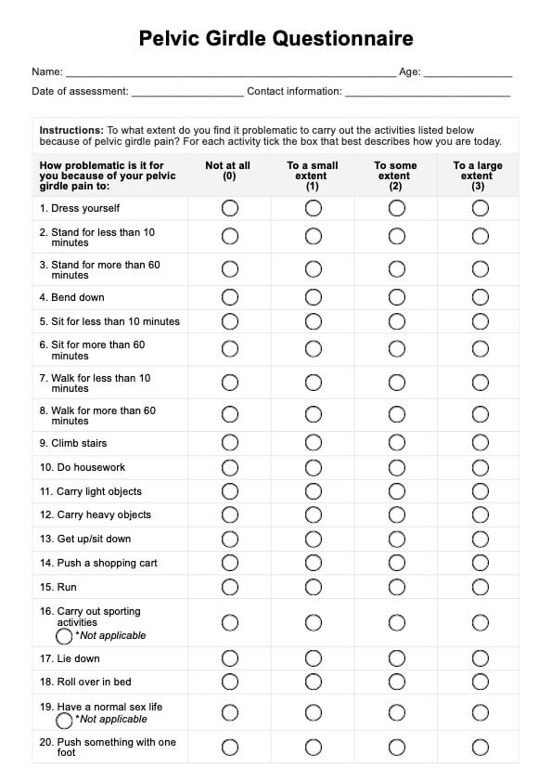

Oswestry Disability Index
The Oswestry Disability Index (ODI) has been extensively used in studies of pelvic girdle pain, capturing functional limitations across multiple domains. ^{[64]}


Psychosocial Assessment Tools
Tampa Scale for Kinesiophobia
The Tampa Scale for Kinesiophobia (TSK) measures fear of movement, which is an important treatment target for graded activity interventions. ^{[63]}
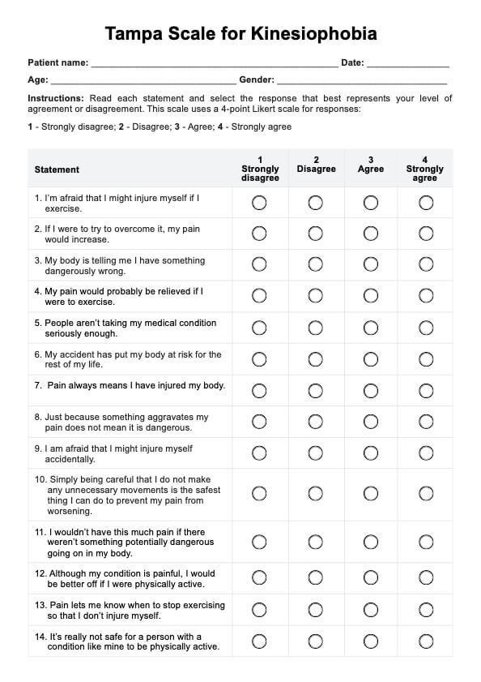

Hospital Anxiety and Depression Scale
The Hospital Anxiety and Depression Scale (HADS) provides screening for psychological distress.
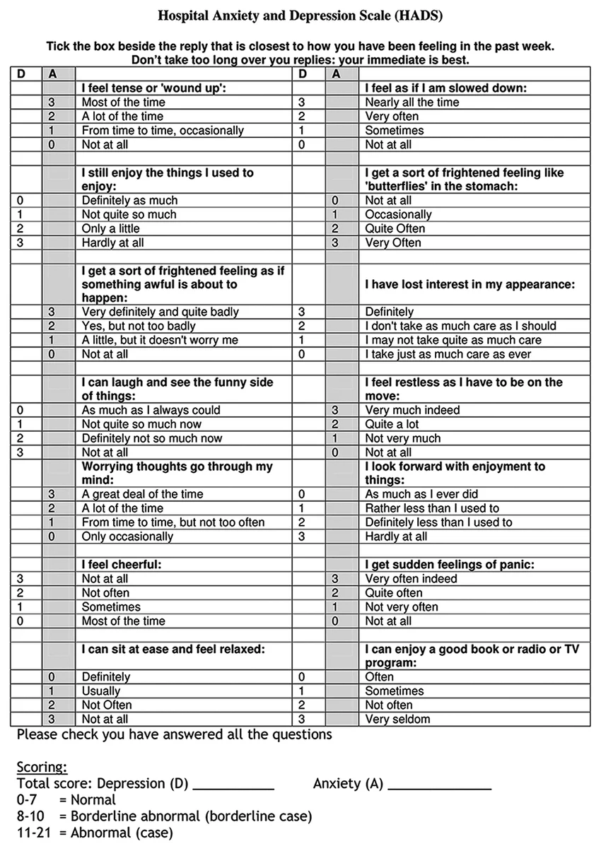

GRADED ACTIVITY-BASED PHYSIOTHERAPY

GRADED ACTIVITY-BASED PHYSIOTHERAPY
Definition
Graded activity-based physiotherapy is a therapeutic approach that involves the systematic and progressive increase of physical activity and functional engagement through a structured, individually tailored program of exercise and functional tasks. The approach is grounded in behavioral medicine principles, particularly operant conditioning theory, and integrates biomechanical knowledge with cognitive and behavioral strategies to address the multidimensional nature of musculoskeletal pain conditions. The term graded activity specifically refers to the systematic, progressive nature of the activity increase, where grade implies a stepwise, measured approach that is calibrated to the individual's current capacity and progressively advanced over time. ^{[54]}

Lindström and colleagues adapted behavioral principles for the management of subacute low back pain to develop a graded activity program that combined operant conditioning with a progressive exercise protocol. It involved patients with subacute low back pain symptoms lasting 6-8 weeks who were at risk of developing chronic pain and prolonged work absence. The intervention included:
- baseline assessment of functional capacity
- establishment of individualized functional goals related to work tasks,
- progressive exercise program that was advanced on a time-contingent basis
- positive reinforcement of activity engagement and functional improvement
- education about the nature of pain and the importance of activity for recovery.

Their landmark randomized controlled trial demonstrated that patients who participated in graded activity returned to work significantly faster than those receiving conventional treatment. This study is widely regarded as the foundation for the subsequent widespread adoption of graded activity in musculoskeletal physiotherapy. ^{[56]}

In pelvic girdle pain, the approach involves careful assessment of the patient's current functional capacity, identification of specific functional goals, and the development of an individually tailored program that progressively challenges the patient's physical abilities while remaining within tolerable limits. The program addresses both the physical dimension of the condition through progressive loading of the pelvic girdle stabilizing structures and the psychological dimension through education, cognitive restructuring, and behavioral strategies that address fear, avoidance, and low self-efficacy. ^{[57]}

Principles
The core principles in graded activity-based physiotherapy are derived from behavioral psychology in operant conditioning theory, exercise physiology in progressive overload and adaptation, motor learning in skill acquisition and motor control, pain science in central sensitization and pain modulation, and cognitive psychology in self-efficacy theory and cognitive restructuring. These provide the theoretical and practical framework for the design and implementation of graded activity programs. ^{[54]}

Progressive Loading
Physical activities and exercises are introduced at a level that the patient can successfully perform and are progressively increased in intensity, duration, or complexity over time. The progression follows a pre-determined schedule rather than being adjusted based on pain levels, ensuring that the patient is progressively challenged regardless of day-to-day symptom variation. This is based on the understanding that tissues adapt to progressive loading by increasing their strength, endurance, and functional capacity, and that insufficient loading results in suboptimal adaptation, while excessive loading may result in tissue damage and exacerbation of symptoms. ^{[56]}

Quota-Based Progression
Specific targets or quotas are established for each exercise or activity, and the patient is expected to meet these targets regardless of their pain level on any given day. By removing the influence of pain on activity progression, this approach helps to break the association between pain and activity limitation, reducing the behavioral reinforcement of pain-contingent rest. Quotas are typically set slightly above the patient’s current comfortable performance level, providing a challenge that is achievable but requires effort. ^{[55]}

Time-Contingent Progression
The advancement of activities is based on time and pre-established quotas rather than on pain reports. This approach helps to decouple the relationship between pain and activity, reducing the patient's reliance on pain as a guide for what they can safely do. The time-contingent approach is based on the understanding that pain is an unreliable guide to tissue damage, and that using pain as a guide for activity levels perpetuates the fear-avoidance cycle and reinforces the association between pain and limitation. ^{[59]}

Comprehensive Pain Education
Patients receive detailed education about pain physiology, which helps understand that some discomfort during rehabilitation is expected and does not indicate tissue damage, and that progressive activity is essential for tissue adaptation and functional improvement. The pain education component of graded activity programs recognizes that pain is produced by the brain in response to perceived threat, that pain does not always correlate with tissue damage, and that the nervous system can become sensitized to pain signals, amplifying the pain experience. By understanding these concepts, patients are better equipped to interpret their pain accurately and to engage in rehabilitation without excessive fear. ^{[60]}

Functional Goal Setting
Treatment goals are framed in terms of specific functional activities that are meaningful to the patient, rather than in terms of pain reduction alone. Functional goals should be specific, measurable, achievable, relevant, and time-bound (SMART), and should be developed collaboratively between the patient and the therapist to evaluate progress. ^{[61]}

Positive Reinforcement
Successful completion of activity quotas is acknowledged and reinforced, promoting continued engagement and effort. Reinforcement can take many forms, including verbal praise from the therapist, self-monitoring charts that visually demonstrate progress, social recognition from family and peers, and the intrinsic satisfaction of achieving meaningful goals. The systematic application of reinforcement principles distinguishes graded activity from simple exercise programs and contributes to its behavioral foundation. ^{[55]}

Self-Management and Self-Efficacy Enhancement
Patients are progressively encouraged to take responsibility for their own rehabilitation, developing the skills and confidence needed to manage their condition independently. Enhancement of self-efficacy occurs through multiple mechanisms, including mastery experiences successfully performing progressively challenging tasks, vicarious experiences observing others successfully performing similar tasks, verbal persuasion encouragement from the therapist, and physiological feedback. ^{[62]}

Individualization
Graded activity programs are tailored to the individual patient's presentation, functional goals, and psychosocial context. The specific exercises, progression rates, and behavioral strategies are adjusted based on ongoing assessment and patient feedback, ensuring that the program remains challenging but achievable. Individualization recognizes that each patient presents with a unique combination of biomechanical dysfunction, neuromuscular impairment, psychological factors, and social circumstances, and that the optimal treatment program must address this unique combination. ^{[63]}

Improved Functional Capacity
The improvement in physical capacity promotes tissue adaptation, neuromuscular efficiency, increased strength of the pelvic girdle stabilizing muscles, improved endurance for sustained postural control, enhanced motor control and coordination of the lumbopelvic muscles, and increased tolerance for weight-bearing activities. These physical improvements translate directly into improved ability to perform the functional tasks like being able to stand on one leg to dress, walk for 30 minutes without pain, climb stairs using a reciprocal pattern, able to turn in bed without pain and able to lift and carry an infant. ^{[65]}

Reduced Fear of Movement
Through the systematic exposure to feared activities in a controlled and supportive environment, graded activity reduces kinesiophobia and promotes re-engagement with activities that the patient has been avoiding. ^{[66]}

Reduced Pain Intensity
The mechanisms underlying pain reduction include improved tissue capacity, reduced central sensitization, the release of endogenous analgesic substances during exercise, and the psychological benefits of active coping. ^{[67]}

Prevention of Chronicity
Early intervention with graded activity may prevent the transition from acute to persistent pelvic girdle pain by addressing the physical and psychological factors that contribute to chronicity, including deconditioning, fear-avoidance beliefs, and maladaptive coping strategies. By intervening early in the course of the condition, graded activity can interrupt the cycle of pain, avoidance, deconditioning, and further pain. ^{[68]}

Improved Quality of Life
The cumulative effect of improved functional capacity, reduced pain, and enhanced psychological well-being is a significant improvement in overall quality of life, allowing women to return to activities and roles that are meaningful to them. Quality of life improvements encompass physical, psychological, and social domains, reflecting the comprehensive nature of the graded activity approach. Women who successfully complete graded activity programs report improvements in their ability to participate in family life, social activities, occupational roles, and recreational pursuits, contributing to a substantially enhanced overall quality of life. ^{[69]}

Components
A comprehensive graded activity-based physiotherapy program for women with pelvic girdle pain includes patient education, cognitive restructuring, a progressive exercise program, behavioral components, and functional integration. ^{[57]}

The exercise component follows a structured progression from basic activation of the deep stabilizing muscles to complex functional movement patterns, progressing through four phases: muscle activation and motor control training, static stabilization, dynamic stabilization, and functional training. ^{[65]}

Physiotherapy Techniques
Deep muscle activation training involves teaching patients to isolate and activate the transversus abdominis, multifidus, and pelvic floor muscles correctly. ^{[63]}

Motor control exercises progress from leg loading exercises in supine to quadruped exercises and side-lying strengthening for gluteal and hip abductor muscles. ^{[65]}

Functional movement training involves breaking down complex movements into component parts and teaching efficient, pain-reducing strategies. ^{[66]}

Strengthening exercises for the hip and trunk muscles are introduced progressively with emphasis on functional movement patterns. ^{[67]}

Aerobic conditioning addresses the cardiovascular deconditioning that commonly accompanies reduced activity levels. ^{[68]}

EFFECTIVENESS OF GRADED ACTIVITY-BASED PHYSIOTHERAPY IN IMPROVING FUNCTIONAL ACTIVITY

EFFECTIVENESS OF GRADED ACTIVITY-BASED PHYSIOTHERAPY IN IMPROVING FUNCTIONAL ACTIVITY

Evidence from Randomized Controlled Trials
The strongest evidence comes from trials by Stuge and colleagues and Elden and colleagues, both demonstrating significant improvements in pain, disability, and quality of life following progressive exercise interventions. The trial by Stuge and colleagues incorporated many key elements of graded activity, including progressive exercises, functional goal setting, and time-contingent progression. ^{[7, 77]}

Evidence from Systematic Reviews
The Cochrane review by Liddle and Pennick provides the most comprehensive synthesis of evidence regarding interventions for pelvic girdle pain, concluding that exercise programs reduce pain and disability. Van Dongen found that individualized exercise programs had the strongest evidence for effectiveness in the management of pelvic girdle pain. ^{[70]}

Mechanisms of Functional Improvement
The mechanisms by which graded activity-based physiotherapy improves functional activity involve multiple adaptations. Peripheral adaptations include tissue strengthening, improved muscle strength and endurance, and enhanced connective tissue resilience. Central adaptations include reduced nervous system sensitization, recalibrated relationship between movement and pain, and improved pain modulation. Cognitive and behavioral changes include reduced fear of movement, improved self-efficacy, enhanced coping strategies, and increased engagement in valued activities. ^{[66]}

Factors Influencing Treatment Response
Several factors influence the response to graded activity-based physiotherapy, including baseline disability, psychological factors, duration of symptoms, and adherence to the program. Patients with higher baseline disability tend to have greater absolute improvement but may require longer treatment duration. ^{[43]}
DISCUSSION

DISCUSSION
The evidence reviewed in this paper consistently supports the effectiveness of graded activity-based physiotherapy in improving functional activity in women with pelvic girdle pain. The available literature demonstrates that progressive, exercise-based interventions incorporating behavioral principles produce clinically meaningful improvements in pain intensity, functional capacity, and quality of life. The importance of integrating biomechanical and behavioral approaches in the management of pelvic girdle pain. Traditional approaches that focus exclusively on either the biomechanical or the behavioral aspects have been shown to be less effective than approaches that combine both elements. The biomechanical component addresses the force closure insufficiency through progressive activation and strengthening of the deep stabilizing muscles. The behavioral component addresses the fear-avoidance cycle through progressive exposure and cognitive restructuring. ^{[59]}

Early intervention with graded activity-based physiotherapy may prevent the transition from acute to persistent pelvic girdle pain. The progression of activities should be based on functional goals and time-contingent schedules rather than pain levels. Graded activity principles should be integrated into the patient's daily routine rather than being confined to formal exercise sessions. Relatively few randomized controlled trials have specifically examined graded activity-based physiotherapy for pelvic girdle pain. The specific components of graded activity programs vary across studies, making it difficult to determine optimal treatment parameters. Most studies have methodological limitations, including small sample sizes, lack of blinding, and heterogeneity in outcome measures. Economic evaluations are needed to determine the cost-effectiveness of graded activity-based physiotherapy relative to other treatment approaches. ^{[71]}

CONCLUSION

CONCLUSION
This study aims to evaluate the effectiveness of graded activity-based physiotherapy in improving functional activity in women with pelvic girdle pain. Graded activity-based physiotherapy is a useful treatment approach that focuses on gradually increasing physical activity, improving functional capacity, and promoting participation in daily activities.

The intervention is intended to reduce pain-related limitations, improve physical functioning, and enhance the ability of women to perform daily activities with greater ease and confidence.

The outcome measures obtained before and after the intervention can help determine the extent of improvement in pain, functional activity, and overall physical performance. If favourable changes are observed, graded activity-based physiotherapy may be considered a beneficial approach for managing pelvic girdle pain in women.

Therefore, graded activity-based physiotherapy may be a valuable component of rehabilitation for women with pelvic girdle pain.

REFERENCES

REFERENCES
- Vleeming A, Albert HB, Östgaard HC, et al. European guidelines for the diagnosis and treatment of pelvic girdle pain. Eur Spine J. 2008;17(3):373-383.
- Wu WH, Meijer OG, Bruijn SM, et al. On the clinical distinction of pelvic girdle pain and low back pain. Eur Spine J. 2002;11(Suppl 2):S134-S136.
- Gutke A, Östgaard HC, Öberg B. Pelvic girdle pain and lumbar pain in pregnancy: epidemiology and classification. Eur Spine J. 2008;17(6):735-741.
- Östgaard HC, Andersson GB, Karlsson K. Prevalence of back pain in pregnancy. Spine. 1991;16(5):549-552.
- Mens JM, Vleeming A, Stoeckart R, et al. Understanding peripartum pelvic pain: implications of a patient survey. Spine. 1996;21(11):1363-1370.
- Albert H, Godskesen M, Westergaard J. Prognosis in four syndromes of pregnancy-related pelvic pain. Acta Obstet Gynecol Scand. 2001;80(6):505-510.
- Stuge B, Veierød MB, Laerum E, et al. The efficacy of a treatment program focusing on specific stabilizing exercises for pelvic girdle pain after pregnancy: a randomized controlled trial. Spine. 2004;29(4):351-359.
- Vleeming A, Volkers AC, Snijders CJ, et al. Relation between form and function in the sacroiliac joint. Part I: Clinical anatomical aspects. Spine. 1990;15(2):130-136.
- Richardson CA, Hodges PW, Hides JA. Therapeutic Exercise for Lumbopelvic Stabilization: The Evidence. 2nd ed. Edinburgh: Churchill Livingstone; 2004.
- Vleeming A, Stoeckart R, Volkers AC, et al. Relation between form and function in the sacroiliac joint. Part II: Biomechanical aspects. Spine. 1990;15(2):137-142.
- Snijders CJ, Vleeming A, Stoeckart R. Transfer of lumbosacral load to the pelvis. Clin Biomech. 1993;8(6):285-294.
- Tague RG. Big-bodied males help us recognize that the origin of pelvic sex differences is birthing, not bisexuality. Anat Rec. 2016;299(2):313-322.
- Sturesson B, Udén A, Onsten I. An axially loaded CT study of the lumbar spine in asymptomatic individuals. Spine. 2000;25(6):690-695.
- Pel JJM, Spoor CW, Pool-Goudzwaard AL, et al. Biomechanical analysis of reducing pelvic girdle pain. J Biomech. 2008;41(10):2213-2218.
- Grob KR, Neuhuber WL, Kissling RO. Innervation of the sacroiliac joint of the human. Z Rheumatol. 1995;54(2):117-122.
- Mens JM, Pool-Goudzwaard A, Stam HJ. Mobility of the pelvic joints in pregnancy-related lumbopelvic pain: a systematic review. Eur Spine J. 2009;18(7):1033-1039.
- Damen L, Buyruk HM, Güler-Uysal F, et al. The effect of pelvic belt positioning on the laxity of the sacroiliac joints during pregnancy. Eur Spine J. 2002;11(4):340-345.
- MacLennan AH. The role of relaxin in pelvic girdle pain. Eur Spine J. 2013;22(Suppl 4):S17-S21.
- Owens K, Pearson A, Mason G. Symphysis pubis dysfunction. The Obstetrician and Gynaecologist. 2002;4(3):118-122.
- Pool-Goudzwaard AL, Vleeming A, Stoeckart R, et al. Insufficient lumbopelvic stability: a clinical model. Man Ther. 1998;3(4):192-201.
- Willard FH, Vleeming A, Schuenke MD, et al. The thoracolumbar fascia. J Anat. 2012;221(4):367-372.
- Vleeming A, Pool-Goudzwaard AL, Stoeckart R, et al. The posterior layer of the thoracolumbar fascia. Spine. 1995;20(4):453-463.
- Fauber J, Kozin SH, Yenchik CG, et al. Anatomy of the inguinal region and femoral triangle. Clin Sports Med. 2006;25(1):1-15.
- Bergmark A. Stability of the lumbar spine: a study in mechanical engineering. Acta Orthop Scand Suppl. 1989;230:1-54.
- Richardson CA, Snijders CJ, Hides JA, et al. The relation between the transversus abdominis muscles, sacroiliac joint mechanics, and low back pain. Spine. 2002;27(4):399-405.
- Hodges PW, Richardson CA. Contraction of the abdominal muscles associated with movement of the lower limb. Phys Ther. 1997;77(2):132-144.
- Hodges PW, Sapsford R, Pengel LHM. Postural and respiratory functions of the pelvic floor muscles. Neurourol Urodyn. 2007;26(3):362-371.
- Sapsford RR, Hodges PW, Richardson CA, et al. Co-activation of the abdominal and pelvic floor muscles during voluntary exercises. Neurourol Urodyn. 2001;20(1):31-42.
- Gutke A, Boissonnault J, Öberg B, et al. Severity of pelvic girdle pain in pregnancy: a cross-sectional study. Spine. 2018;43(5):E239-E246.
- Van De Pol G, Van Brummen HJ, Bruinse HW, et al. Pregnancy-related pelvic girdle pain in the Netherlands. Acta Obstet Gynecol Scand. 2007;86(4):416-422.
- Olsson C, Nilsson-Wikmar L. Health-related quality of life and physical ability among pregnant women with and without back pain in late pregnancy. Acta Obstet Gynecol Scand. 2004;83(4):351-357.
- Wu W, Meijer OG, Jutte JH, et al. Gait in patients with pelvic girdle pain: a systematic review. Eur Spine J. 2002;11(6):527-535.
- Nilsson-Wikmar L, Holm K, Oijerstedt R, et al. Effect of three different physical treatments on pain and activity in pregnant women with pelvic girdle pain: a randomized clinical trial. Eur Spine J. 2005;14(4):371-378.
- Coldron T, Crothers E, Haslam J. Effective management of pelvic girdle pain. J Assoc Chart Physiother Womens Health. 2005;97:39-50.
- Gutke A, Östgaard HC, Öberg B. Predicting persistent pregnancy-related low back pain and pelvic girdle pain. Spine. 2008;33(12):E386-E393.
- Persson M, Winkvist A, Dahlgren L, et al. Physical activity and obstetric pain: a prospective study. BJOG. 2003;110(5):465-471.
- Cowan S, Coldron T, Crothers E, et al. Guidelines for the physiotherapy management of pelvic girdle pain from pregnancy and childbirth. J Assoc Chart Physiother Womens Health. 2005;97:39-50.
- Foti T, Davis JR, Bagwell JA, et al. Biomechanical analysis of gait during pregnancy. J Bone Joint Surg Am. 2000;82(5):619-620.
- Björklund K, Bergström S. Is pelvic pain in pregnancy a reliable predictor of pelvic pain in future pregnancies? Acta Obstet Gynecol Scand. 2000;79(4):280-285.
- Østgaard HC, Andersson GB, Wenngren BI, et al. Influence of back pain and disability on labor. J Clin Epidemiol. 1993;46(1):25-30.
- Dunning DW, Brackley MB, Savignon AD, et al. Traumatic pelvic fractures. Orthop Nurs. 2006;25(4):243-248.
- Röst C. Relieving Pelvic Pain During and After Pregnancy: How Women Can Overcome Chronic Pelvic Pain. London: Christie and Christie; 2011.
- Braun J, Sieper J. Ankylosing spondylitis. Lancet. 2007;369(9570):1379-1390.
- Cohen SP, Chen Y, Neufeld NJ. Sacroiliac joint pain: a comprehensive review of epidemiology, diagnosis and treatment. Expert Rev Neurother. 2013;13(1):99-116.
- Hungerford B, Gilleard W, Lee D. Alteration of pelvic bone kinematics in subjects with posterior pelvic pain. Man Ther. 2004;9(4):198-205.
- Fordyce WE. Behavioral Methods for Chronic Pain and Illness. St. Louis: C.V. Mosby Company; 1976.
- Vlaeyen JW, de Jong J, Geilen M, et al. The treatment of fear of movement/(re)injury in chronic low back pain: further evidence on the effectiveness of exposure in vivo. Clin J Pain. 2002;18(4):251-261.
- Sullivan MJ, Ward LC, Tripp D, et al. Secondary prevention of work disability: community-based psychosocial intervention for musculoskeletal disorders. J Occup Rehabil. 2005;15(3):377-392.
- Moseley GL, Nicholas MK, Hodges PW. A randomized controlled trial of intensive neurophysiology education in chronic low back pain. Clin J Pain. 2004;20(5):324-330.
- Bandura A. Self-efficacy: toward a unifying theory of behavioral change. Psychol Rev. 1977;84(2):191-215.
- Bandura A. Self-Efficacy: The Exercise of Control. New York: W.H. Freeman and Company; 1997.
- Laslett M, Aprill CN, McDonald B, et al. Diagnosis of sacroiliac joint pain: validity of individual provocation tests and composites of tests. Man Ther. 2005;10(3):207-218.
- Mens JM, Vleeming A, Snijders CJ, et al. The active straight leg raising test and mobility of the pelvic joints. Eur Spine J. 1999;8(6):468-473.
- Richardson C, Jull G, Hodges P, et al. Therapeutic Exercise for Spinal Segmental Stabilization in Low Back Pain. Edinburgh: Churchill Livingstone; 1999.
- Moseley GL. A pain neuromatrix approach to patients with chronic pain. Man Ther. 2003;8(3):130-140.
- Leeuw M, Goossens ME, Linton SJ, et al. The fear-avoidance model of musculoskeletal pain: current state of scientific evidence. J Behav Med. 2007;30(1):77-94.
- Ware JE Jr, Sherbourne CD. The MOS 36-item short-form health survey (SF-36): I. Conceptual framework and item selection. Med Care. 1992;30(6):473-483.
- Waddell G. The Back Pain Revolution. 2nd ed. Edinburgh: Churchill Livingstone; 2004.
- Van Tulder MW, Koes B, Malmivaara A. Outcome of non-invasive treatment modalities on back pain: an evidence-based review. Eur Spine J. 2006;15(Suppl 1):S64-S81.
- Price DD, McGrath PA, Rafii A, et al. The validation of visual analog scales as ratio scale measures for chronic and experimental pain. Pain. 1983;17(1):45-56.
- Kuijpers T, van der Heijden GJ, Ostelo RW, et al. The Pelvic Girdle Questionnaire: a condition-specific questionnaire for pregnancy-related pelvic girdle pain. Phys Ther. 2013;93(7):954-963.
- Fairbank JC, Pynsent PB. The Oswestry Disability Index. Spine. 2000;25(22):2940-2952.
- Miller RP, Kori SH, Todd DD. The Tampa Scale: a measure of kinesiophobia. Clin J Pain. 1991;7(1):51.
- Mousavi SJ, Parnianpour M, Mehdian H, et al. The Oswestry Disability Index, the Roland-Morris Disability Questionnaire, and the Quebec Back Pain Disability Scale. Spine. 2006;31(14):E454-E459.
- Elden H, Haglund H, Olsen MF, et al. Regression of pelvic girdle pain: a randomized controlled trial. BJOG. 2016;123(6):1021-1031.
- Liddle SD, Pennick V. Interventions for preventing and treating pelvic and back pain in pregnancy. Cochrane Database Syst Rev. 2015;(9):CD001139.
- Van Dongen JM, Van den Berg T, Sherburn M, et al. Effectiveness of conservative interventions for the management of pelvic girdle pain: a systematic review. Man Ther. 2015;20(3):412-420.
- O'Sullivan PB. Cognitive functional therapy for chronic low back pain. Phys Ther Rev. 2004;9(1):43-52.
- Sturesson B, Udén G, Udén A. Pain pattern in pregnancy and "catching" of the leg. Spine. 1997;22(16):1880-1883.
- Östgaard HC, Roos-Hansson E, Zetherström G. Regression of back and posterior pelvic pain after pregnancy. Spine. 1996;21(23):2777-2780.
- Östgaard HC, Zetherström G, Roos-Hansson E. Back pain in relation to pregnancy and influence of physical activity. Spine. 1997;22(18):2103-2106.
- Östgaard HC, Andersson GB. Previous low back pain and risk of developing back pain during pregnancy. J Occup Environ Med. 1997;39(5):481-485.
- Mogren IM. Previous physical activity and its relationship to back pain during pregnancy. J Obstet Gynaecol. 2005;25(2):126-132.
- Kristiansson P, Svärdsudd K, von Schoultz B. Serum relaxin, symphyseal pain, and back pain during pregnancy. Am J Obstet Gynecol. 1996;175(5):1342-1346.
- Damen L, Buyruk HM, Güler-Uysal F, et al. Pelvic pain during pregnancy is associated with asymmetric laxity of the sacroiliac joints. Acta Obstet Gynecol Scand. 2001;80(11):1019-1024.
- Comerford MJ, Mottram SL. Functional stability re-training: principles and strategies for managing mechanical dysfunction. Man Ther. 2001;6(1):15-26.

